Sangster PTA Meeting Minutes September 10, 2020
Attendance: 67 Meeting called to order at 7:04 pm
Principal Update from Lisa Reddel
Back to School Night September 15th with two live sessions. Sign in with student’s secured BBCU link. Only one device can log on to the student’s link at a time.
Tentatively scheduled for the week of September 28th will be a materials pick-up assembled by teachers for their students. The pick- up will be organized in a similar fashion to previous ones using the oldest and/or only schedule.
Minutes Review
Motion to approve by Karen Horvath, 2nd by VP Denise Siderys and Jennifer Campbell. Majority approval through hand raise and comments chat.
Treasurer Report by Tammy Moffitt
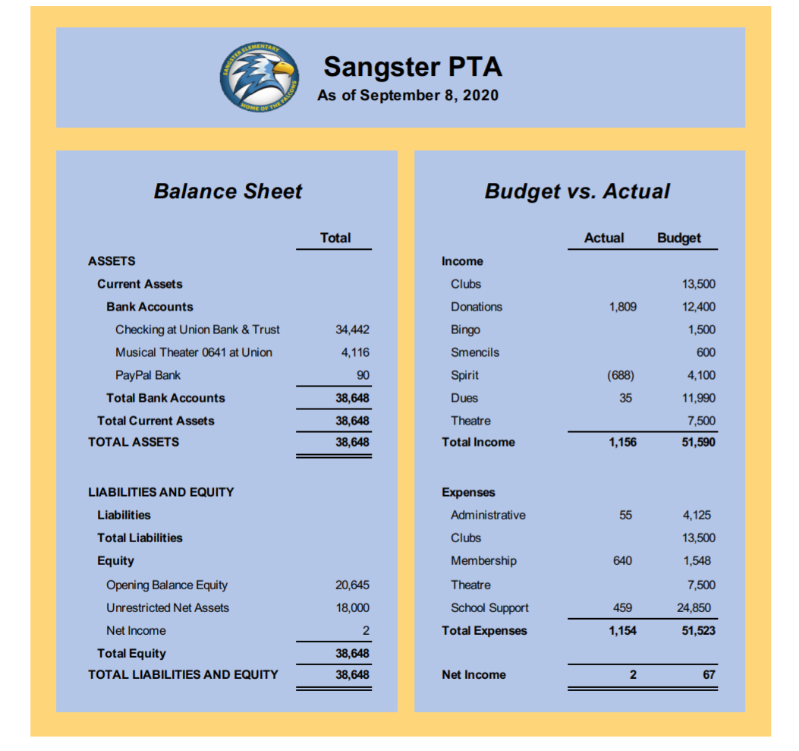
PTA business transition by Karen Horvath
New Officer appointment: Vice President- Denise Siderys
Committee Reports:
Welcoming Committee -Aubree Caunter
Ongoing link available through the PTA website to connect new families with existing Sangster families.
After Back to School Night small group coffee dates will be organized for those who sign up to build community.
Directory/MemberHub- Connie Genne/Tammy Moffitt
Directory and PTA functions will be transitioning to online only. There will be no hard copies of the directory this year. PTA membership will include the digital directory as well as many other benefits. All of these will be coming soon to our new MemberHub page.
Reflections- Cherilyn McCall. Submissions due by October 9th. Questions and requests for more information can be emailed to Reflections@SangsterPTA.org.
Clubs- Christine Moniz
Chess Club, Math Club, Odyssey of the Mind, Run Fit Kids, and Fencing are still continuing this school year. Information can all be found on the PTA website.
Fundraising- We will be losing an estimated $30,000 in PTA funds this year due to last years canceled carnival and the possibility of losing this Springs carnival as well due to COVID.
Falcon missions/yard signs- Kimber Vega
Falcon missions still available for $20 and you can purchase your own Sangster yard sign for $15 on our MemberHub site at sangster.new.memberhub.store/store
Restaurants/Fall Auction- Jacquelyn Fant and Sara Hanni
September 29th will be the first restaurant fundraiser at the Burke Chipotle from 5-9pm. Chipotle will give back 33% to Sangster PTA that night. Information will be posted on Facebook and News You Choose.
October 25TH - November 1ST Online Auction including the raffle items from last Spring that will be arranged into baskets. Other items to include professional sports team, winery and popular kids’ items.
Spirit Wear- Darcy Kim
T-shirts, mask, long sleeve shirts and sweatshirts will all be available for purchase at our MemberHub site soon. Ordered items will be shipped to the purchasers’ home address. All proceeds to benefit the Sangster PTA.
Closing comments/Questions
When requesting permission to join PTA Facebook or Military Spouses Group of Sangster, please fill out all of the security questions and check the box that you will agree to the terms of membership.
Next meeting will be Thursday October 8th.
Meeting adjourned 7:51PM

