Sangster PTA Meeting November 19th 2020
Attendance:36 Called to order at 7:02 pm

Principals Update: Alison Jankovich/Jennifer Redford

Dr Brabrand addressed the pause on phased reopening at a Town Hall tonight held at 6pm. Reminder that all dates are subject to change based upon COVID indicators. There has not been a new Group 5 start date projected.

Sangster has prepared for phased reopening by implementing:
-visual aids
- marking off spots for mask breaks
- inside cleaning and decluttering
- IA and Staff support schedule for beginning and end of school day
- classroom set up with social distance
- student materials ordered
- technology upgrades and additions
- PPE sorted and allocated to teachers
- approved recess equipment with sanitation procedures
- air systems checked, cleaned and approved for safety.

Free cold lunches will be provided if desired for all in-person students through June.

If an in-person student becomes ill, a Permission to Return to School/Child Care Form must be filled out before a student may return to in-person learning. Clear instruction regarding student illness and procedure is on the Parent/Guardian Commitment Form which must be turned in before a child may return to in-person learning.

Student photos and a yearbook are in the works. Individual photos will be scheduled for February 1st & 8th. No club or candid photos will be included, however, personalized ads for 6th graders will be available for purchase. A Shutterfly account will be set up for contributions to the 2020-2021 yearbook.

Minutes Review: Karen Horvath
Approved with majority vote of 19 ayes in Chat
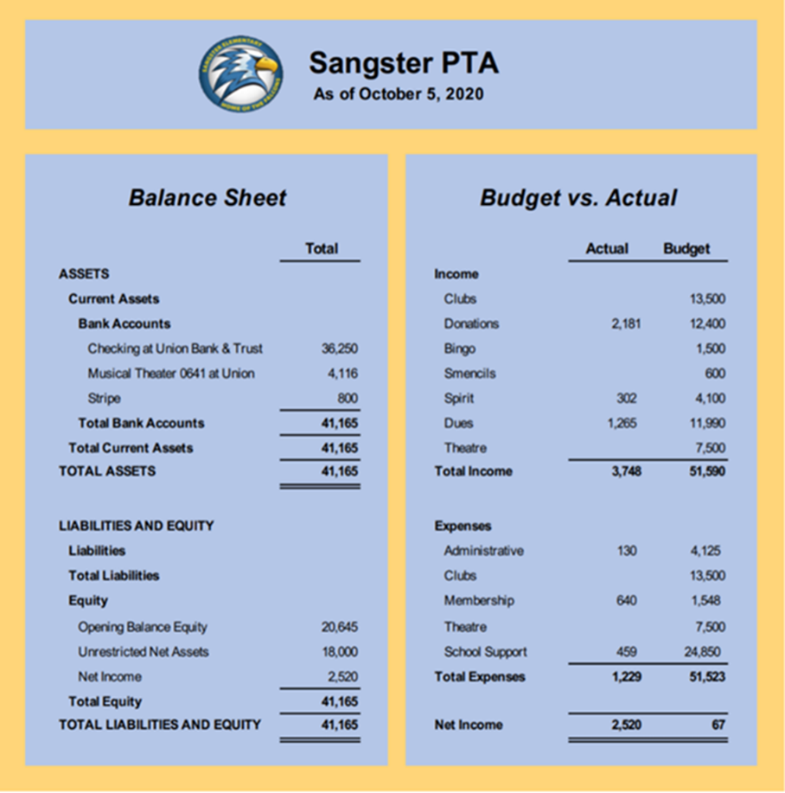
Treasurer’s Report: Tammy Moffit
$5,000 in revenue from October Auction. Possible -$8500 from decreased price of membership along with fewer people joining (149members to date vs 229 last year). Approved with majority vote of 19 ayes in Chat

Audit: Tammy Moffit
Completed audit can be viewed on MemberHub: https://sangster.memberhub.com/flies.
Approved with majority vote of 19 ayes in Chat.

Upcoming Dates:
11/ 23- 1st and 2nd grade materials pick-up from 3:30-5:30
11/24- Nominations close for FCPS Employee Awards
11/25-11/27- No School for Thanksgiving Holiday

Committee Reports:
Fundraising: Jackie Fant/Sara Hanni
Auction - $5000 in Revenue
Restaurant nights: December 15th at Panera in Springfield
Hospitality: Rai Rasouli/Denise Siderys
60 Thanksgiving Pies ordered for Teachers and Staff
Reflections: Cherilyn McCall
4 Sangster winners. The three 1st place winners will go on to the next level
Rock Garden Update: Karen Horvath
Installation coming soon. Labor and materials donated by Mr Horvath and his company.
Falcon Missions: Karen Horvath
Thank you, Kimberly Vega for piloting this fundraiser. The new leader will be Sara Ahmad.

Sangster RULER Social-emotional program: Maggie Wilkerson and Meghan Buckles

Visit the Counselors website to learn more about how to implement RULER, the development of emotional intelligence, at home. https://sites.google.com/view/sangster-es-counselors/parents-home-page?authuser=0

Questions and Comments:
-Boxtops have gone virtual.
-Volunteers are always welcome. Email volunteers@sangsterpta.org if you would like to be contacted when we have opportunities coming up!

Next Meeting is scheduled for December 10th @ 7pm via Zoom
Meeting Adjourned at 8:08pm

