Sangster PTA Meeting Minutes December 9th, 2020
Attendance:30 Called to order at 7:05pm

Principals Update Alison Jankovich/Jennifer Redford
- Spirit Week: December 14th-18th
- Teacher Gift Drop Off/Materials Pick-up: December 14th and 15th
- Holiday Break 12/21-1/1
- Return to In-Person learning is on hold
- School Board Meeting 12/10
- January 12th may be a potential return to in-person date beginning by phasing in one group per week and splitting Group 7 into 3rd/4th and 5th/6th. At that time the new bell Schedule of 10:05-4:50pm will go into effect. It is not clear if the virtual bell schedule will match the in-person schedule.
- Continued Building prep for student return.
- Safety Team visiting Sangster for a walk-thru December 11th to ensure mitigation strategies meet the county standards.

Minutes Review Karen Horvath Approved: 19 votes in chat box
Treasurer’s Report Tammy Moffit Approved: 21 votes in chat box
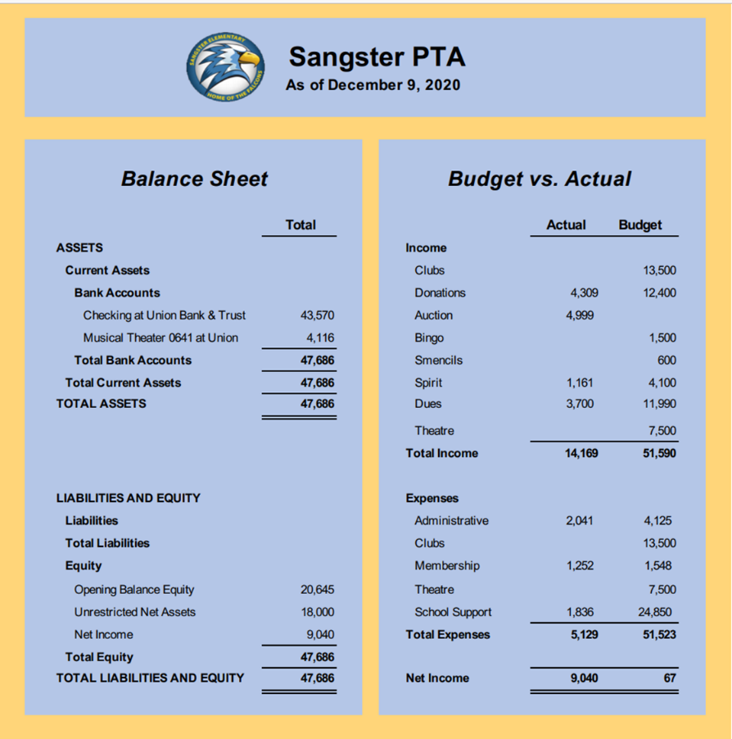
This year we have collected less than the previous year in dues and spirit wear and the Smencils sale has not been viable. There has not been an allocation of program funds. The PTA currently holds a $9,000 surplus.

Holiday sweater/hat contest! Debbie Gaydos won the drawing

Committee Reports:
Fundraising Jackie Fant
- Read-a-thon: Will be scheduled for early 2021
Restaurant nights:
- Noodles & Co: last month
- Panera: December 15th from 4-8pm. Use code advertised on Facebook to order online.
Hospitality
- Thanksgiving Pies: Thank you to Rai Rasouli and Denise for planning and execution!
- December teacher snacks: Will be dropped off at Sangster by Lara Swinger for all staff and teachers to pick up.
Events and Activities:
  - Rock Garden Update: Karen Horvath Almost finished!
  - Valentines Bingo: This will be a virtual event hosted by Ms Jankovich and Ms Redford. Bingo bags will be assembled and picked up in a similar fashion to the Boo Bags. Bags will include Bingo cards, daubers and prizes. Sign up and sales will be done through MemberHub.
MemberHub is up and running!
  - PTA Membership
  - Sign up and pay for fundraising events
  - Access the Directory

Next meeting will be Thursday January 14th 7pm
Meeting Adjourned 7:38pm

