Sangster PTA Meeting Minutes January 14, 2020
Attendance:36 Called to order at 7:03pm

Principals Update Alison Jankovich
- Welcome to our new acting assistant principal Cindy Agner.
- Vaccine sign-ups for Sangster Staff have started
- Feb 2nd District work session to plan Return to Learn.
- School photos from LifeTouch will be Feb 1st and 8th. There is a link on the Sangster home page for appointments through SignUp Genius and the order form. Payment must be made before photo shoot. More yearbook information will be available in next week’s NYC.
- 71 new teacher laptops are being distributed. Additional 498 computers have been received as a tech refresh for grades 3-5. If your child has an issue with their laptop, please contact the front office.
- Feb 11th report cards will go out.
- Technology etiquette will be taught in classrooms.

Minutes Review Karen Horvath Approved: 21 votes in chat box
Treasurer’s Report Tammy Moffit Approved: 23 votes in chat box
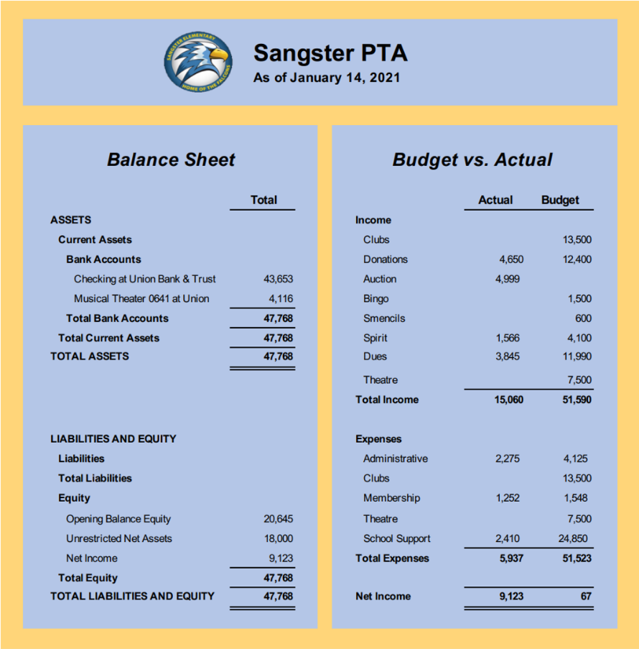
Recent Fundraising: Spirit Wear $404.51, Noodles & Co $117.66, Panera $173.58

Committee Reports:
Fundraising Jackie Fant
- Read-a-thon: Is tentatively scheduled for March 2021
- Restaurant nights will be announced as they are scheduled (Jan/Feb)
Spirit Wear
- A new order will open soon
Hospitality
- Teacher Appreciation is in the works for possible Jan/Feb distribution.
Cultural Arts:
- Ms Redford and Carolyn Brace are planning a virtual assembly.
Events and Activities:
- Valentine’s Day Bingo: Scheduled for Feb 11th @ 7pm. Bingo bags filled with cards, daubers, and prizes will be for sale through MemberHub with contactless pick-up scheduled the weekend prior.
- Virginia PTA “Thank a Teacher” Art Contest: Open to all FCPS Students through Feb 1st. Three winners, one from elementary, middle and high, will be chosen to win a cash prize, have their art featured on PTA thank you notes and an additional cash prize for their school.
- Rock Garden: The garden is up-front for those who would like to add to it or get additional unpainted rocks from the rear section to paint and return.
Volunteers needed for Valentine’s Day Bingo and Teacher Appreciation activities. Email Volunteers@SangsterPTA.org

FCPS Digital Citizenship presentation by Mrs Tannenbaum- Slides and presentation may be viewed with the Zoom link on the PTA webpage.

Next meeting will be Thursday February 18th 7pm
Meeting Adjourned 7:47pm

