Sangster PTA Meeting Minutes February 18, 2021
Attendance:42 Called to order at 7:03pm

Principals Update Alison Jankovich
- Link to Virtual School Tour will be emailed in February 19th NYC
- If you need to check your student out early, 3:45 will be the latest you may do so during a school day.
- Emergency changes to student transportation must go through the main office.
- 9:35 is the earliest that Kiss and Ride or students that walk may be dropped off.
- Grassy area is the designated spot for parent drop-off and pick-up of walkers.
- Laptops need to come to school with a full charge. Power cords do not need to come to school with students.
- Parent information nights are as follows:
  - Kindergarten: February 17, 2021
  - 1st & 2nd: March 3rd, 6:30-7:30 pm
  - 3rd-6th: March 10th, 6:30-7:30pm
- If you have further questions; contact information will be published in NYC or you may email Ms. Jankovich directly.
- Return to Sangster dates:
  - Kindergarten: February 23rd
  - 1st & 2nd: March 9th
  - 3rd-6th: March 16th
- Letters will be emailed out for each child with their teacher’s name, school days, transportation and if they are going to receive school lunch. Please check over all of your selections to ensure accuracy.

Minutes Review Karen Horvath Approved: 25 votes in chat box (36 attendees at time of vote) Noted: Year needs to be corrected on January Minutes.
Treasurer’s Report Tammy Moffit Approved: 23 votes in chat box (35 attendees at time of vote)
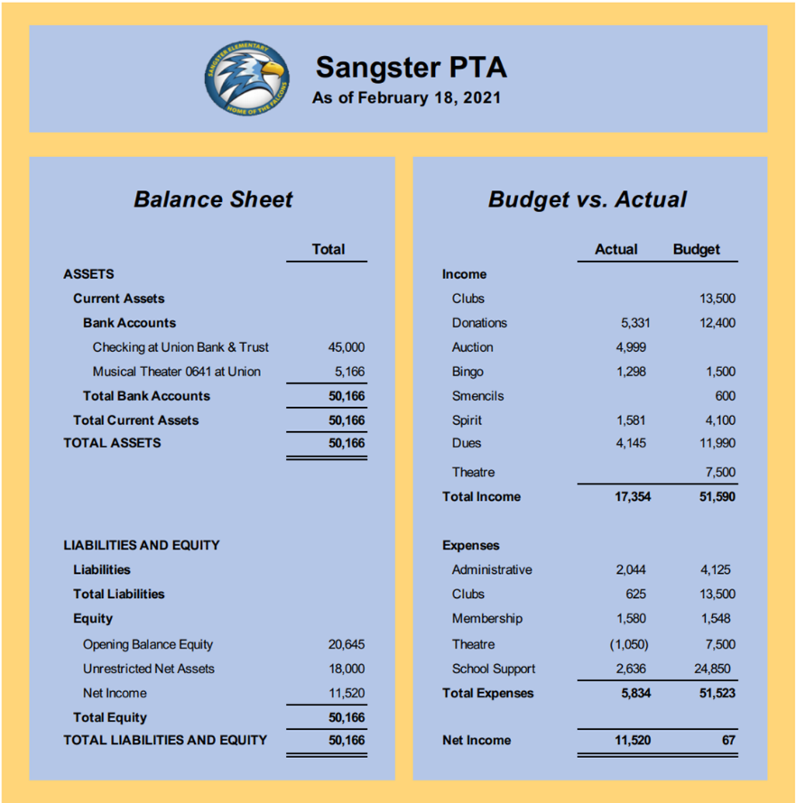
Reserves Total $50,166 Programmatic funds of approximately $600 to support Girl Scout Troop 5551 with their service project of building a free lending library for Sangster. Currently, the account is showing a $11,520 surplus for the year.

Committee Reports:
Bingo was a huge success!
- Thank you, Julie Moore and all of the volunteers that helped to put it together.
6th Grade Ceremony
- We need volunteers to organize the T-shirts and celebration. Volunteers@SangsterPTA.org
SPROUT Order
- Robyn Chew is working out the details for next school year
Community Outreach
- Jami O’Neill has organized a food collection Monday, March 1st from 3-5pm for non-perishable foods and house hold necessities to support local families that need assistance. Drop off of donations will be in the bus loop.
Spirit Wear
- A new order will open within the next few weeks
Hospitality
- March will be our next event.
Cultural Arts:
- Ms. Redford and Carolyn Brace are planning a virtual assembly for March. There will be separate assemblies for K-3rd and 4th -6th.
Family Paint Night
- A ZOOM painting lesson by a celebrity Sangster teacher is in the works for March. All supplies will be sold in a bag similar to Bingo for purchase on MemberHub. More info to come!
Safety Committee
- Lauren Cole did some research into contacting VDOT about adding speed humps and extra parking spaces to make the school zone safer. Karen is continuing the effort as we transition back into the school building.
Fundraising/Restaurant Nights
- Feb 23rd & 24th: Marcos Pizza
- March: Possibly Auld Shebeen Irish Pub
Thank YOU!!!!
Jill Mitchell: Volunteer Co-Ordinator
Haylee Bernstein: PTA Website
Yearbook
    - Yearbook information will be published in NYC
    - Special 6th grade highlights
    - Candid shots requested
Next meeting will be Thursday, March 11th at 7pm
Meeting Adjourned 8:07pm

