Sangster PTA Meeting Minutes March 11, 2021
Attendance:25 Called to order at 7:05pm

Welcoming comments by Karen Horvath.
Principals Update from Ms. Jankovich:
  - Grade level Return to Learn information and video links are posted on the Sangster web site. Return to School Information (Effective 2/16/2021) | Sangster Elementary School (fcps.edu)
  - Grades 3-6 WILL need to bring their charging cords to school with them.
  - Playground structure is officially open for school use. 1 group/class in the play area at a time on a rotating schedule.
  - PTA donated playground balls are in use.
  - Breakfast opt in/out for students has been sent out through a link in NYC.
  - Ms. Jankovich is up for an administration review. Please take the time to fill out the survey.
  - SOL’s are currently scheduled for April 26-May 21
  - Around 100 students took the in person IOWA test this year and it went smoothly.
  - A quick review of how the money was spent that was allotted to Sangster for COVID:
    - Cares Act purchases $1,200: Virex, gloves, spray bottles, hand sanitizer, visors, masks, and Clorox wipes.
    - Technology $32500: 19 web cameras, 24 document cameras, 45 24’’ monitors, 12 projectors, and 34 docking stations.
  - If you have changed your preference and would like to drop off your students, please let the school know so that other people that would like a seat on the bus can have that choice.
  - If you are using Kiss and Ride, please be patient. Kinks are still be worked out with drop off and pick up. Your patience is greatly appreciated!
  - Yearbook photos need to be submitted by March 16th through Shutterfly.
  - There is a secured drop box out front of Sangster to deposit items that need to get to staff and teachers. Please clearly mark who they are for before dropping them in the box.
Minutes Review by Karen Horvath: Approved with 22 votes in favor
Treasure’s Report by Tammy Moffit: Approved with 17 votes in favor
- Short fall of estimated $7,700 in dues. Events is a new item line item in the report with Paint Night as a new activity. Odyssey of the Mind is using funds from last year. Share the Love event will come up short $6,000 this year of which $4,000 of it would have been a PTA expense. PTA is projected to have over a $9,000 surplus by the end of the year.

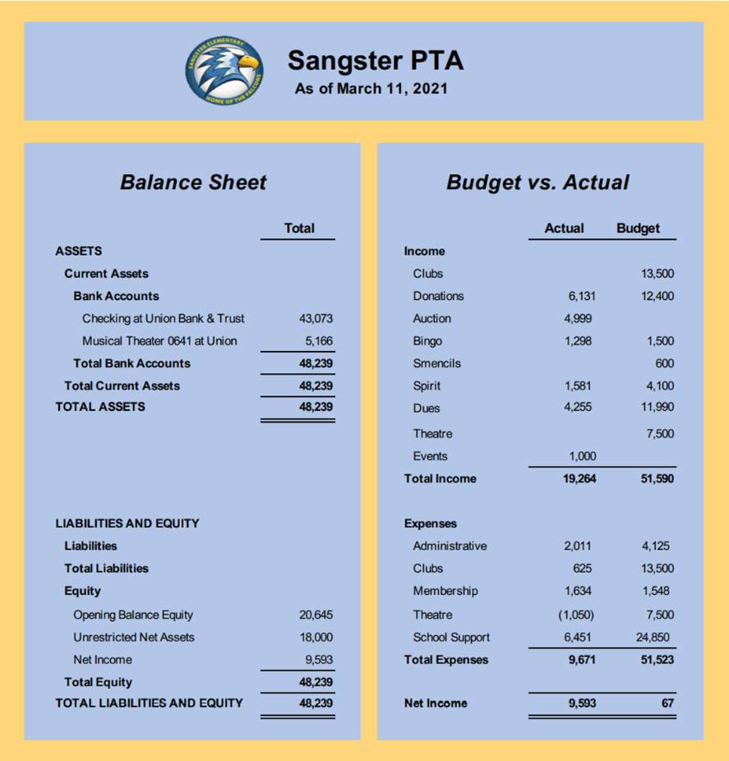
Upcoming Activities: Lara Swinger
- PTA Paint Night with Mrs. Reese will be from 7-8 pm on March 15th. 100 spots sold out within 24hrs. The PTA is currently looking for volunteers to help with the next event. Many thanks to the volunteers that helped to make this event possible; Mrs. Reese, Julie Moore, Karen Horvath, Tammy Moffit, Liz O’Hanlon, Julie Eason, Sally Anne Cleveland.
- We need more volunteers! Please email volunteers@SangsterPTA.org to volunteer your time or talent. Thank you, Jill Mitchell, for connecting our volunteers with committees!
- The Sangster Military Spouses Group is also seeking volunteers to fill board positions.
Community Outreach: Jami O’Neill
- School collection was a success! Mrs. Wilkerson delivered donations to Sangster families in need. We would like to make these kinds of donations more frequent on our calendars.
Spirit wear: Darcy Kim
- Merchandise is being finalized and we would like to be able to sell merchandise ion person if we make a bulk order.
Fundraising: Denise Siderys
- March 22nd from 11am-9pm The Auld Shebeen Irish Pub & Restaurant in Fairfax will give 15% back to Sangster. Dine-in or carry out, delivery is not offered for this restaurant. More to come on FaceBook and Twitter!

Hospitality: Rai Rasouli
- Morning donuts for teachers and staff will be delivered to Sangster before Spring break!
Cultural Arts: Ms Redford and Carolyn Brace
- March 22nd Sangster will have virtual assemblies G
- Grades K-3 will see Nana Puddin’
- Grades 4-6 will see Flow Circus.
- Information and links will be given to students by their teachers.
Our next meeting will be Thursday, April 8th at 7pm.
Meeting adjourned at 7:58

