Sangster PTA Meeting Minutes May 27, 2021
Attendance: 25 Called to order at 7:05 pm
- Principal Update: Ms. Jankovich/ Mrs. Agner/ Ms. Redford
  - Laptops, chargers and library books will be collected June 9th & 10th for in-person students. Virtual students will return their items on June 14thwith more information about that to come. Please do not try to return laptop sleeves. Students will need to keep them for the next school year.
  - Staff that will not be returning to Sangster next year include; Marian Hoelscher, Susan Autio, Doris MacDonald, Ann Rollins, Mandy Rice, Natalie Ryan, Dawn Reese, Joseph Kim, Heather Ahlers, Jennifer Brotemarkle, Jennifer Zukas, and Karen Smialek. Best wishes and continued success to all.
  - Staff returning next year include; Meghan Buckles, Jean-Marie Boyle, Jessica Yun, Christina Krockel.
  - New staff introduced includes; Evelyn Allen, Angela Sung, Shawn Zortman and Whitney Dearman.
  - Congratualtions to Ann Pritz and Alexis Yang for their SEPTA nominations and recognitions this year!
  - 6th grade promotion will be June 9th at Lake Braddock, 6:30pm. So far 170 students have RSVP’d with their 2 allowed guests for attendance.
  - June 10th will be a 6th grade car parade/staff dinner at Sangster for students to come get cheers from their teachers and see the Falcon in the fence that was donated by the PTA.
  - 6th grade t-shirts are for sale now! Don’t wait.
  - Sangster will not be an ESY(extended school year) location this summer but we will have programs for grades 1-6 by invitation only. There will also be a bridge to Kindergarten program for three weeks starting July 13th and ending July 30th from 9:30-1:40 during the week days.
  - Parks and Rec has been given permission to hold some programs at Sangster this summer.
  - June 8th is an Election Day. ALL students will be virtual from 9:45-4-15 pm.
  - School Hour for the 2021-2022 school year have been set for 9:10-3:55 pm.
  - Parents and teacher feedback about ticks in the fields has been addressed. The school building and outer perimeter have been sprayed along with increased grass cutting and edging.
  - Kiss and Ride on Reservation drive has created some neighborhood tensions. Please do not block driveways! Busses have been made available to anyone that has requested transportation. Please try not to get into the pick-up/drop-off line super early. The line moves quickly and arriving early only creates extra congestion and hazards.
  - Yearbooks will arrive June 10th. There will be a limited number for sale on site.
- Minutes Review: Karen Horvath VOTE: 16 in favor, motion passed
- Treasurers Report: Tammy Moffitt VOTE: 19 in favor, motion passed
- 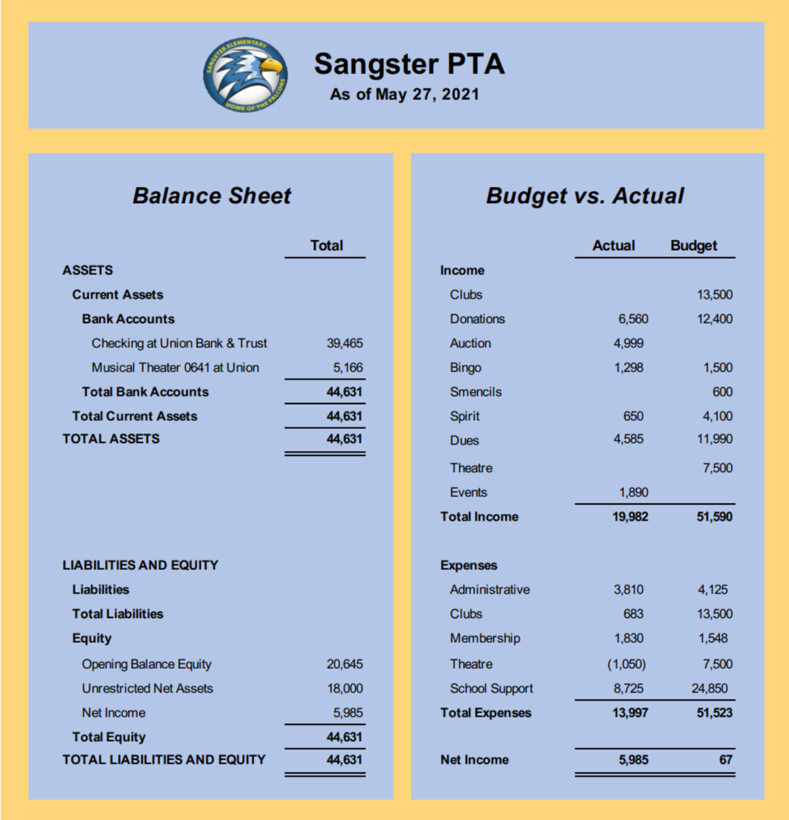
- PTA Board Nomination/election VOTE: 17 in favor, motion passed
  - Nomination Committee Chair: Sally-Anne Cleveland
    - President: Karen Horvath
    - Vice President: Erin Straub
    - Secretary: Lara Swinger
    - Treasurer: Tammy Moffit

- Cultural Arts: Carolyn Brace:
Kate Messner, childrens book author, will be in a video virtual visit. There will be a book giveaway, one per class, as part of this event.
- Kona Ice Truck visit: Monday June 7th, 5-7pm at Sangster
  - All students get tickets for a free small ice. Sibling ices available for purchase for $3, CASH ONLY!!
- Spirit Wear sale: Monday June 7th, 5-7pm at Sangster
T-shirts, Hoodies, Water bottles. Request for another round of personalized water bottle sales.
Volunteers are needed for the following committees:
Welcoming committee:
Provide information to new families
Help coordinate a new family popsicle/playground event
Reflections:
PTA sponsored local program
Coordinate arts program for judging
Facilitate collection of students artwork on a particular theme
Spanish Club:
Facilitate Global Plus language program for K-3
If you are interested in any of these programs, please email Jill Mitchell at
Volunteers@SangsterPTA.org
- Clubs: Christina Collins
  - This weekend is the Virtual World Finals for Odyssey of the Mind. We have 6 teams competing!
  - Our Kindergarten/1st grade team is one of four US teams competing this year. Great job on your success!
- Sprout School Supplies: Online sale through July 13th. Get all of your school supplies sent directly to the school and support the PTA.
Meeting Closed 8:04 pm

