PTA Meeting, September 9th, 2021
Start: 7:00pm Attendance: 65
Principal Update- Allison Jankovich
New Staff Welcome: Virginia Regan(6th grade), Whitney Dierman(4th grade), Karen Sappington(5th grade AAP), Rielly Wall(2nd grade), Elizabeth Speight(1st grade), Sean Zortman(4th grade), Diane Lewis(4th grade), Kazim Sulvucci(ESOL), Jackie Balough(SIA), Angela Sung(Art), Cristina McCape(STEAM), Evelyn Allen(Music), Anna Chavez(IA), Nikki Panagakis(Dining Assistant), Alex Wooten(Office Assistant Sub), Hillary Yee(PHTA), Ellen Fraedrich(Band), Blanca Grande Perez(Cafeteria Manager), Melissa Batrla(Dining Assistant), Karen Kleiber(Interim Vice Principal through November 2021), Jennifer Redford(Assistant VP).
20th Anniversary of 9/11: Will be observed Friday with message from Ms. Jankovich to the students and staff followed by a moment of silence. The County has provided discussion points for grades 3-6.
Lunch and Snacks: Thank you for trusting the planning!
- Currently there are 122 kids (+/-) in the cafeteria spread over 36 tables (no more than 4 students to a table).
- Some classes are eating in the classroom.
- 6 new volunteers for the cafeteria/classroom that are in the processes of being vetted.
- Snacks are being eaten outside when possible.
- Teachers are spacing students out to the greatest extent possible when they cannot be outdoors.
Other precautions:
- Teachers are moving seats, removing furniture additional furniture and taping boundaries on the floors in attempt to provide clear social distancing boundaries.
- Seating charts are utilized through out the day for possible contact tracing.
- PTA and a parent have donated a county approved air purifier for the cafeteria.
- Recently tables have been placed under the outdoor tent. The county may provide extra funds to hire and train monitors to supervise the area during food breaks.
COVID Notifications:
- We have had our first Sangster positive case.
- An email was sent Friday with the summary to the community.
- If your child/student is ever directly exposed, Ms. Jankovich will personally contact you before an email summary goes out.
- After Ms. Jankovich does her investigation, the Health Department takes over all communication.
- There have been lots of quarantines but only the one case traced back to Sangster.
- Asynchronous Work is currently being provided to students that are under quarantine. The county is looking into one-way live streaming options for lessons. Nothing is definite, but the possibility is being discussed.
- If your child is sick, keep them home. If you send them to school and they get sent home from the Care room, they will need a health care provider to sign the return to school form before they may come back inside the building.
- You do not need a note or COVID test if you voluntarily keep your child home for a sick day. The only need to be fever free for 24 hours without any medication.
Academics: Testing/Assessment Season will begin shortly.
- Virginia Growth Assessment
- PALS(Kindergarten) Readiness Assessment
- iReady Math and Reading (Grades 1-6): Assessments will be given in class between September 8th -October 29th. Additional information can be found at https://www.fcps.edu/us or you may contact Ms. Redford.
- SEL/Social Emotional Learning (Grades K-6): Grades 3-6 will take a 10-minute self-reported assessment in class this fall, winter and spring. K-2 will be teacher lead in the winter and spring. Parents and teacher will have access to the assessment results. Visit the website https://www.fcps.edu?node/43892, or contact Ms. Redford, Mrs. Railan or Mrs. Augenstein if you have further questions.

School improvement plan will be made public shortly.
Feedback is welcome!

Meeting Minutes Review- Karen Horvath
Minutes approved; 64 in attendance with 36 in favor.
PTA Budget 2021-2022- Prepared by Tammy Moffitt, presented by Erin Straub
Budget approved; 63 in attendance with 37 in favor.
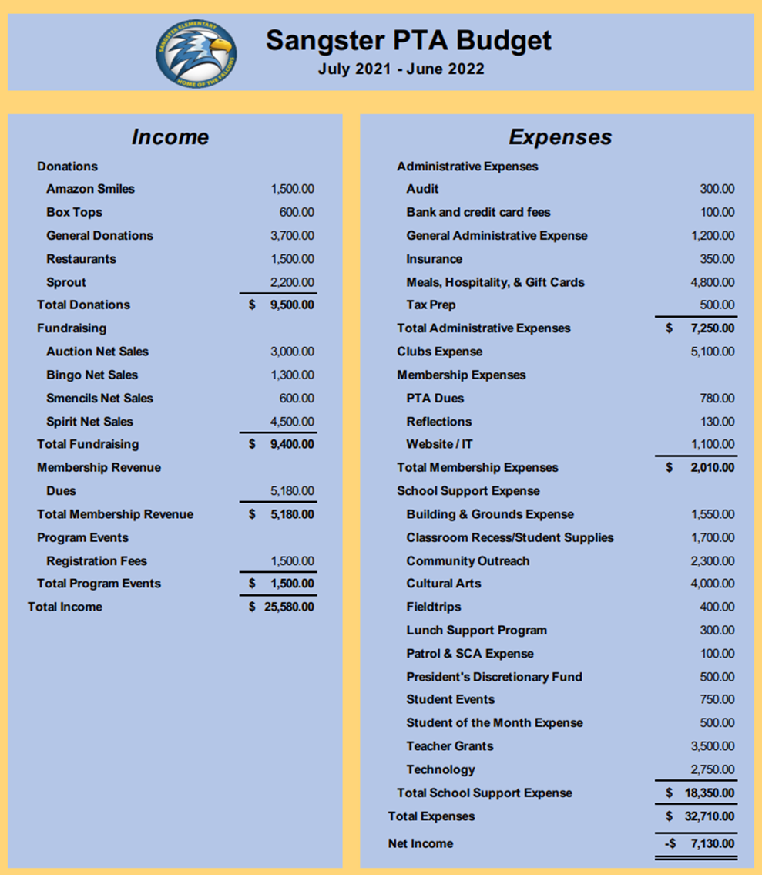

PTA Back to School Events- Karen Horvath
- New Family Welcome with popsicles on the playground
- Hospitality provided breakfast for teachers
- Mask lanyards and air purifier for the cafeteria
- Teacher Grants
Volunteers Needed- Karen Horvath
- Membership Coordinator
- Falcon Mission Leader
- Clubs Coordinator
- Memberhub Directory Assistant

Email Jill Mitchell at volunteers@SangsterPTA.org
Clubs, Contests and Groups-
- Currently the PTA is offering Math Club, Robotics, Chess, Run Fit Kidz, Fencing, Odyssey of the Mind, Girls Smarts. Fliers will be coming home shortly and contact information can be found on the Sangster PTA website.
- Reflections-
- A multimedia art contest sponsored by the National PTA. This year’s prompt is, “I will change the world by…”
- The Military Spouses Group of Sangster Elementary needs volunteers to coordinate events and member participation. Contact information is under Clubs on the PTA website. MSG@sangsterPTA.org
Rewards Programs- Keri-Marie Cantone
- BoxTops- Scan receipts into the app and they will give money back to Sangster.
- Amazon: Make sure to turn on your donations to Sangster twice a year!
- Raise Right: Currently Scrip e-gift cards are for sale and if you use the App September 16th and 17th Sangster can earn even more!
Fall Activities/Calendar
- September 26th: Popsicles and Spirit Wear 2-4pm
- September 27th Restaurant Night @ Ledo Pizza 5-9pm
- October 7th: PTA Meeting
- October 23rd: Boo bags & Spirit Wear
- October/Rocktober: Rock painting for students
- November 10-14th: Auction
- November 25th: Pies for Teachers
Sprouts School Supplies- Robyn Chew
Sprouts has been renewed for next year. Robyn’s proactive renewal has earned Sangster 5 free kits to be distributed to students in need next year. Thank you!
PTA Website- Haylee Bernstein
The website has been updated with clubs and committee information. Thank you, Haylee!
Join or renew your PTA Membership at https://sangster.memberhub.com/store
Thank you for coming and we will see you on October 7th!
Meeting adjourned 8:05pm

