Sangster Elementary School PTA Meeting October 7, 2021
Called to order at 7:03 Attendance:34
Principal Update- Allison Jankovich
- Blue Ribbon Award: National Award Ceremony November 4th and 5th at the Gaylord Hotel.
- High Performing School
- Based on exemplary ability to close the gap in special ed based on 2018 – 2019 SOLs scores where 92% of students passed the math SOL (from 84% in 2017-18). Maintain over 80% pass rate in reading
- Outdoor Seating: 30 tables have been purchased. Seating charts are still being used. Outdoor seating is weather permitted.
- Student pulled fire alarm 10/8/2021
- COVID update:
  - 1 COVID case will be reported this week. Community exposure does not get factored into the school database.
  - Updated care room procedures. Students can return to school with a negative PRC, Rapid test or a home test. Home test will need a note from whom ever administered the test.
  - Return to School Form is no longer being used.
- School Innovation and Improvement Plan (SIIP): Details will be shared in November.
  - Academic Goal: Reading/Math Special Ed/ESOL
  - Wellness Goal: Coping Strategies
  - Access and Opportunity Goal: Military Connected Students
- Contact Tracing/Updates on Mitigation Strategies/Streaming
- Readvertising AP Position
- Family Liaison Position- Stacy Huisman
  - Background
    - Active duty military spouse and mother of two
    - 10+ years working as military family/student advocate
    - Professional writer/published book author specializing in military-connected students in public schools
    - 25+ years working in community engagement/event planning
  - Contact information:
Stacy Huisman, Family Liaison
Sangster ES and Orange Hunt ES
dshuisman@fcps.edu stacyhuisman@gmail.com 813-205-7923

Assistant Principal Update
- Karen Kleiber: Students out on Pause/Streaming/Check-Ins
  - Research, identify and alert teachers of potential COVID transmission.
  - Start streaming for students that are paused with Language Arts and Math focus lessons in combination with paper work sheets and online programs.
  - Check-ins from teachers and counselors every 2-3 days.
  - Track and communicate return dates.
  - Streaming in combination with home work is only available for students that are “paused” due to COVID.
- Jen Redford: Testing (SEL Screener, CogAt, VGA)
  - VGA- Identifies the gap in learning for the state. Results will be shared and data will be used to plan instruction.
  - CogAt- 2nd Grade: October 13,14,15
  - CogAt- 3rd Grade: October 19, 20, 21
  - SEL- Grades 3-6: October 12-22nd
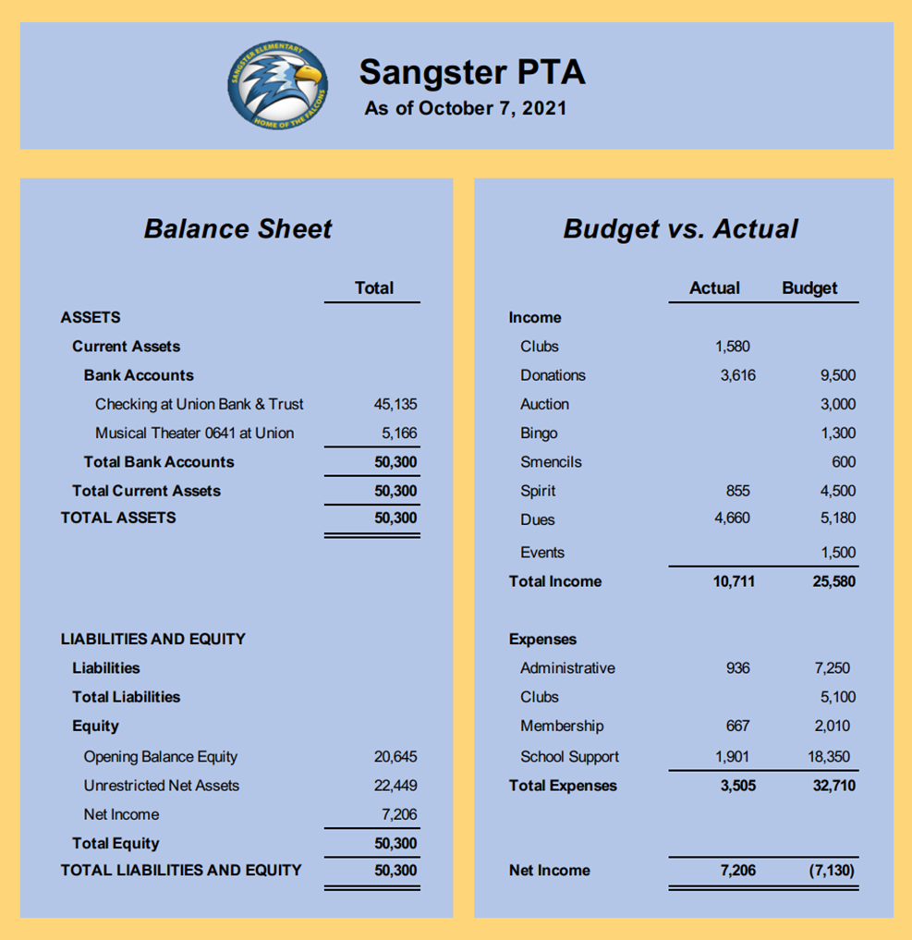
PTA Treasury Report
Report passed with majority vote: 17/29
Budget Amendment: Picnic Tables approved with majority vote: 20/29

Meeting Minutes Review accepted with majority vote: 15/28

Volunteers Needed- Karen Horvath
- Membership Coordinator
- Falcon Missions
- Club Coordinator
- Treasurer for the 2022-2023 School Year
Email Jill Mitchell at volunteers@SangsterPTA.org
Spirit Wear- ONLINE SALE
- Fun new items!
- A link to the website has been posted in October 6th PTA News You Choose, MemberHub and the PTA website.
- Open from now until October 17th.
- Distribution will be the first week of November. Shipment to the buyer’s home is not an option for this sale
- If you have any questions, please email: SPIRITWEAR@sangsterPTA.org
Fall Activities/Calendar
- Boo Bags!
Only $10 per bag. Order can be placed on MemberHub with last day to order on October 22nd. Pickup will be October 23rd from 3-5 & October 25th from 4:30-6:30.
- Rocktober
Clean rocks will be placed in the rock garden at the front of the school. Take them home, paint them and then return them to the school.
- Dates:
  - October 8th: Reflection’s entries are due
  - October 9th: Rocktober! starts
  - October 23rd and 25th: Boo bag pickup
  - October 25th and 26th: Restaurant Night @ Spartans
  - November 10-14th: Auction
  - November 25th: Pies for Teachers
Questions:
Can we purchase outdoor heaters for continued use of new picnic tables during colder weather?
Where are future PTA meeting dates posted for the rest of the 2021-2022 school year?
Meeting adjourned at 7:56pm

