Sangster PTA Meeting Minutes April 14, 2022
Attendance:24 Called to order at 7:02pm

Welcome- PTA President Karen Horvath
Principals Update- Allison Jankovich
1. Welcome back from Spring Break!
2. Staffing Updates for the 2022 – 2023 school year.
*Daniela Lazcano (Kindergarten) – moving/resigning
*Rebecca DeLuzio (2nd Grade) – moving/resigning
*Brittany Leverett (5th Grade) – moving/resigning
*Liane Char (5th Grade) – retiring
*Georgina Tongko (Special Education IA) – resigning
*Sara Field and Mary Moran will both be returning from a Leave of Absence.
3. Class Placements for the 2022 – 2023 School Year & Parent Input for the 2022 – 2023 school year.
Please email Ms. Jankovich at ALJankovich@fcps.edu by June 1st if you want to share anything about your child for the 2022 – 2023 school year. Please write “Placement Information for Sally Smith 2022 – 2023” in the subject line. This is option and NOT mandatory.
4. Teacher Appreciation Week
May 2nd – May 6th, 2022
5. Spring Testing Updates
*Iowa Algebra Aptitude Test (6th Advanced Math) take in January – waiting on results
. Spring Testing Updates
*SEL Screener in K – 6 (K-2 Teacher Completes and 3-6 the students complete
*iReady Screener in Reading and Math
*Kindergarten:
-PALs (Literacy)
-CBRS (Child Behavior Rating Scale)
-Early Math Assessment System (EMAS)
*Student in grades 3 – 6 recently took the Horizon Assessments in Reading and Math
- Math
District Average = 66%
Sangster Average = 80%
- Reading
District Average = 62%
Sangster Average = 77%
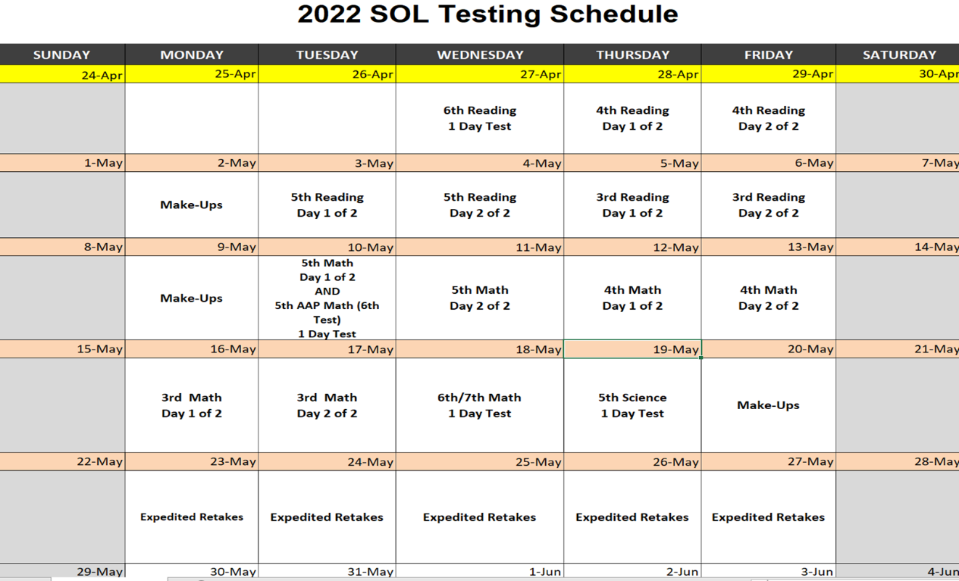
Theater- Jennifer Redford
Back to Broadway: Thursday, June 2nd and Friday, June 3rd at 7pm in the Sangster cafeteria.
May have RSVP for seating compacity No admission price as of right now but donations will be gladly accepted to cover equipment costs.
Month of the Military Child- Stacy Huisman
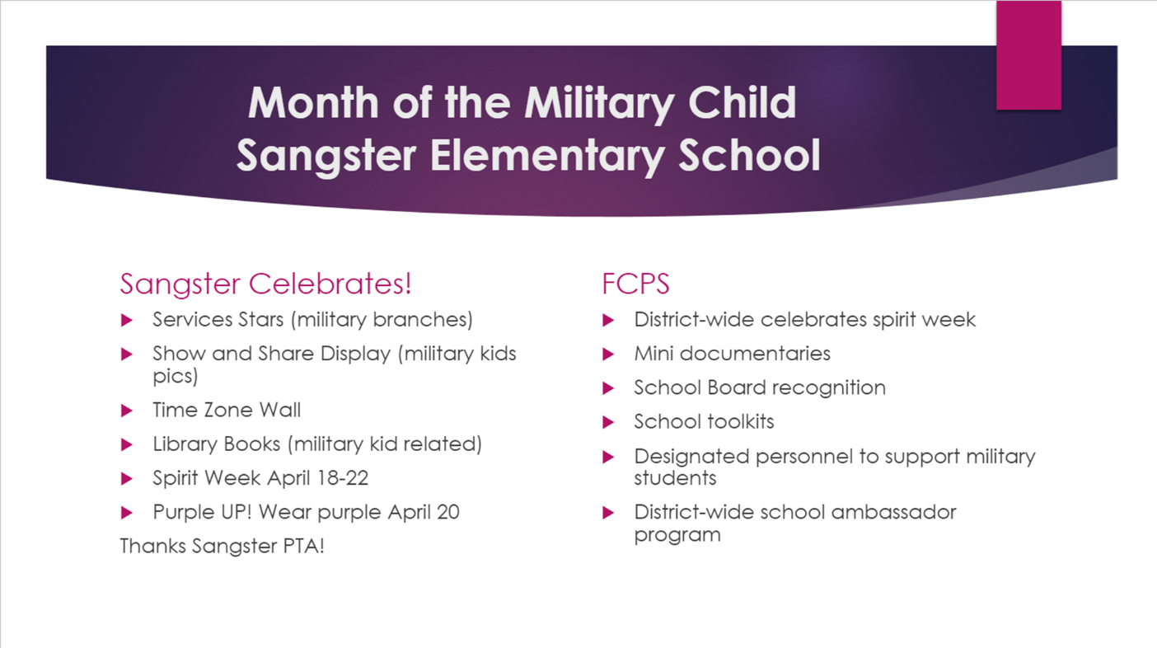
Sprit Week 18-20 (FCPS Wide)
Monday April 18 – Pajama Day
Tuesday, April 18 – Crazy Camo Day
Wednesday, April 20 – WEAR PURPLE for PURPLE UP!
Thursday, April 21 – Wear Stars and Stripes
Friday, April 22 – RED Day – Remember Everybody Deployed
Meeting Minutes Review- Karen Horvath
Vote passed with majority in favor: 19/23
Treasury Report- Submitted by Tammy Moffitt, presented by Erin Straub
Vote passed with majority approval: 15/22
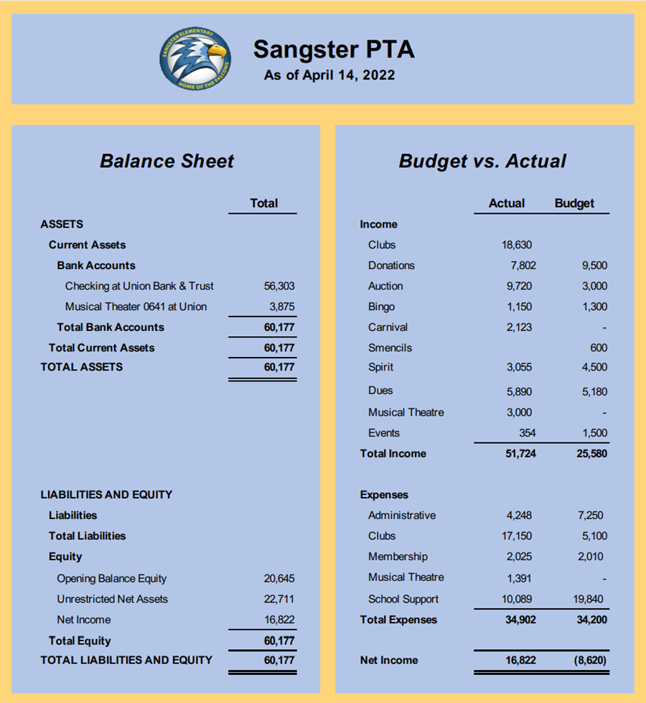

Sprit Week 18-20 (FCPS Wide) – Look for a flyer this week about Spirit Week. But for heads up:
- Monday April 18 – Pajama Day
- Tuesday, April 18 – Crazy Camo Day
- Wednesday, April 20 – WEAR PURPLE for PURPLE UP!
- Thursday, April 21 – Wear Stars and Stripes
- Friday, April 22 – RED Day – Remember Everybody Deployed
Board Nomination SY 2022-2023
Voting will be at the May 5th meeting
Current slate:
- Erin Straub: President
- Lara Swinger: Vice President
- Tiffany Bares: Treasurer
- Sara Smith: Secretary
Nominating committee head is Sally Anne Cleveland
Clubs Updates:
Christina Collins:
- Odyssey of the Mind: 16 teams, 6 teams going to world finals
- Girlsmarts will start final session April 15th.
- Looking at a version of Girlsmarts for boys next year.
- Cartography starts Monday with 3 sessions.
Karen Horvath:
- Chess Club: Sangster is the K-3 Virginia State Chess Team Champions
- Sangster has the K-3 Virginia Chess Individual Champion: Vanya Valoshin
- Math Club: Four Sangster students qualified for the Virginia Mathcounts competition
Purchases:
- Display cabinet for awards and trophies in the lobby
- Teacher wish list items: playground equipment, etc.
- Projected costs: picnic table sanding and finishing
Upcoming Activities:
- Kona Ice truck for Field Day April 19th
- Carnival April 29th
- 6th grade activities:
- Party at the St. James
- Pizza party in class
- Rock garden painting class competition
Volunteers Needed for SY 2022-2023
- Clubs coordinator – club fees waived for one student per year
- Hospitality (2 positions) – coordinate monthly Panera bagel delivery, etc.
- Membership – advertise for membership
- Spirit Wear
Email Jill Mitchell atvolunteers@sangsterpta.org

Join or renew your PTA Membership at https://sangster.memberhub.com/store

Thank you for coming and we will see you on May 5th. This will be our last meeting of the school year!
Meeting adjourned at 7:05pm

