Sangster PTA Meeting Minutes May 5th, 2022
Attendance:14 Called to order at 7:06pm

Welcome- PTA President Karen Horvath
Principal’s Update- Allison Jankovich
- Thank you to Karen, the PTA Board, Committees and all of the volunteers for everything this year. Karen, you will be greatly missed.
- Tons of great feedback from the Spring Carnival.
- Staffing Updates for the 2022 – 2023 school year.
*Daniela Lazcano (Kindergarten) – moving/resigning
*Rebecca DeLuzio (2nd Grade) – moving/resigning
*Brittany Leverett (5th Grade) – moving/resigning
*Liane Char (5th Grade) – retiring
*Georgina Tongko (Special Education IA) – resigning
*Sara Field and Mary Moran will both be returning from a Leave of Absence. 3 new teachers have been hired for next year.
- Class Placements for the 2022 – 2023 School Year & Parent Input for the 2022 – 2023 school year. Please email Ms. Jankovich at ALJankovich@fcps.edu by June 1st if you want to share anything about your child for the 2022 – 2023 school year. Please write “Placement Information for Sally Smith 2022 – 2023” in the subject line. This is optional and NOT mandatory.
- COVID Outbreaks
  - There have been 10 outbreaks. An outbreak is when 3 or more students and/or staff from a class are out with confirmed infection at a time.
  - Ms. Jankovich is monitoring numbers and listening to the Health Department Recommendations.
  - Mitigation strategies include cleaning, remaining 6 ft apart, outdoor seating, and encouraging the use of masks.
- SOL Testing
  - Reading will be completed tomorrow.
  - Math starts next week.
  - Test results have been very good so far.
  - Scores will be sent home with the final report card of the year.
- Summer Programs
  - There will be a few programs using Sangster this summer.
  - 3 combo summer classes will be held for students that have been identified as needing additional support. This will be by invitation only and notification will be sent out via email if your student qualifies for one of these classes.
- Upcoming Events
  - Math Nights, May 24th Last Names A-L, 6-7:30pm
  - Math Night, May 25th Last Names M-Z, 6-7:30pm
  - Field Day with Kona Ice, May 27th
  - Hand Bells, May 27th 6:30 - 7pm
  - Chorus, May 27th 7:15-7:45pm
  - 6th Grade Promotion @ Lake Braddock, June 1st 6:30pm
  - Band, June 7th
  - Last Day of School, June 10th
Meeting Minutes Review- Karen Horvath
Vote passed with all in favor.
990 Form (Treasury)- Karen Horvath
Vote Passed with all in favor.
Treasury Report- Submitted by Tammy Moffitt, presented by Tiffany Bares
Vote passed with majority approval: 11/14
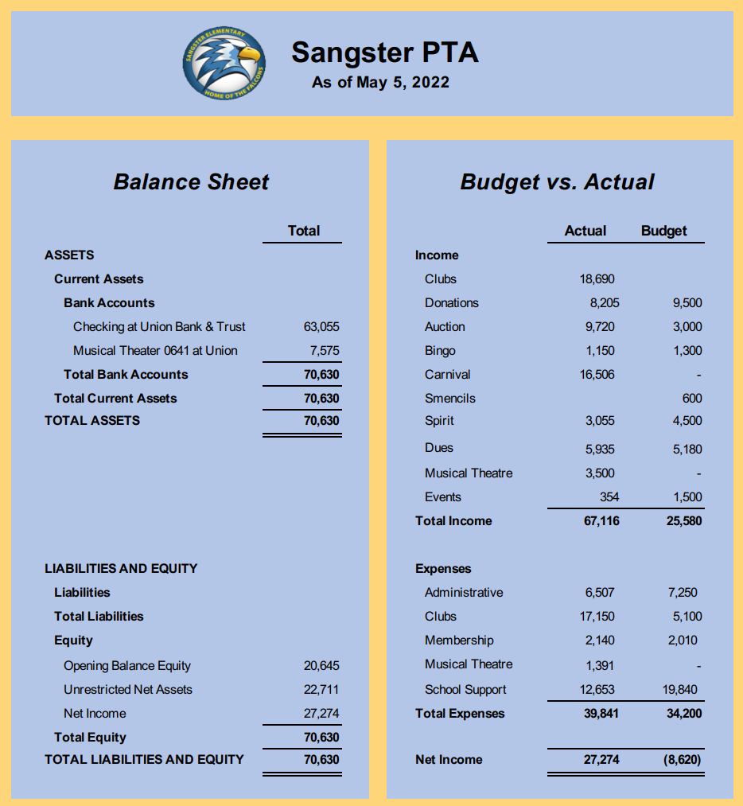

Board Nomination and Election SY 2022-2023- Sally-Anne Cleveland
Board appointed with all in favor:
- Erin Straub: President
- Tiffany Bares: Treasurer
- Lara Swinger: Secretary
Activities Report:
- Carnival was a tremendous success! Huge thanks to our Committee Chairs; Sara Hanni and Denise Siderys, all of the volunteers, and everyone that donated and played at the Carnival. Our PTA raised almost $16,000 during this single event! Please join us at future PTA meetings as we discuss and collect ideas of how we can use our funds to support Sangster students and staff.
  - Suggestion to move non-ticketed activities such as Pie-In-The-Face and Raffle Baskets to an area outside of the gaming zone so that those who do not wish to pay for activities may still participate in other aspects of Carnival.
  - It was also noted that Sangster Administration and the PTA will provide Carnival Sponsorship to families that merit free admission.
- Teacher Appreciation week is celebrated this week.
- PTA sponsored Kona Ice truck for Field Day May 27th
- Cultural Arts: Japanese Drumming Performance, June 7th with 2 outdoor sessions.
- Sprouts School Supplies are now online! Thank you, Robyn, for setting this up.
- 6th grade celebration at St James.
- Class of 2022 signs now being sold on MemberHub.

Clubs Updates: Karen Horvath
- New Clubs Liaison will be Jondrea Crawford
- Reflections Awards assembly was held last week.

Christina Collins:
- Thank you for the display cabinet.
- BoySmarts will start next year.
- Cartography/Geography Club will run October-May next year with weekly meetings.

Volunteers Needed for SY 2022-2023
- Hospitality Cochair– coordinate monthly Panera bagel delivery, etc.
- Membership/Directory
- Spirit Wear
- Celebration/greeting signs at the front of the school.
Email Jill Mitchell atvolunteers@sangsterpta.org
Jill also announced the winners of the Starbucks gift cards for the past two months! Anyone that volunteers is entered for a chance to win the monthly giveaway!
Karen and Tammy,
Thank you for your YEARS of service to our students, teacher and staff through your active roles in the PTA. We are sincerely appreciative for all that you have done!
Thank you for coming. This was our last meeting of the school year!
Meeting adjourned at 8:02pm

