Sangster PTA Meeting Minutes September 22, 2022
Attendance:25 Called to order at 7:01pm
Opening Comments: Erin Straub
Principal Update: Ms. Jankovich
Welcome Back!
  - Fully Staffed
  - Twitter @Sangster_ES/News You Choose
- What’s New and/or Good
  - New-t0-Sangster staff
  - Sangster 6th Grade Class of 2022 recess decorations
  - Back to School Night
  - Pack 684 for their work on the outdoor picnic tables
  - New lobby furniture
- Region 4 Info
  - Dr Michelle Reid, FCPS Superintendent
  - Penny Gros, Assistant Superintendent
  - Lisa Reddel, Executive Principal
  - David Jagels, Executive Principal
  - Laura Jane Cohen, Springfield District School Board Member
- COVID Updates
  - Contact me if your child tests positive for COVID. 5 day isolation period from the date of symptom onset or positive test (Day 0 of 5)
  - Mask Optional
  - Outdoor Seating
- Transportation/Dismissal
  - If your child has an appointment, please pick up no later than 3:30PM. End of day is very busy!
  - Students cannot ride buses home with other students. Please arrange playdates after kids get home.
  - Instruments on buses – going to be different on every bus. Please talk to driver.
  - U Turns on Reservation Drive are being reported.
- Reading Instruction
  - Science of Reading - focus on phonemic awareness, phonics, word study, grammar
    - No more DRA – using other assessments such as iReady, Oral Reading Fluency, Core Phonics, ect will be used.
    - small group differentiated instruction
    - Resources to support instruction
      - Lexia (K-6); Newsela (grades 3-6); No Red Ink (grades 4-6)
- Continuation of Interventions (Wellness and Academic Needs)
- Team Leaders Collaborative Learning Teams (CLT) Training and CLT Reboot for all Staff
- Engaging Instruction
  - Using FCPS resources
  - Transitioning away from virtual learning slide decks
  - Posted Learning Targets
  - Social Emotional Wellness
  - Morning Meeting/ Closing Circle
  - Posted Rules/Expectations
  - Welcoming and Organized Classroom Environment
  - Consistent Parent Communication
  - Wellness Wednesday
- School Innovation and Improvement Plan (SIIP)
  - By the end of the 2022-23 school year, the overall Pass Advanced rate on the 3-6 Grade Reading SOL Tests will increase from 39% to 44% . Additionally, the 3rd grade Reading SOL pass rate will remain at 99%.
  - By the end of the 2022-23 school year, the overall Pass Advanced rate on the 3-6 Grade Math SOL Tests will increase from 46% to 50% . Additionally, the 3rd grade Math SOL pass rate will remain at 99%, reflecting student growth from the previous school year.
- Upcoming Dates/Events:
  - No School for Students Monday, Sept 26th (Teacher Workday)
  - Week of October 3rd – Custodial Appreciation Week
    - Ms. Jane, Mr. Peter, Patricia, Mr. Park, Janet
  - Tuesday, Oct 4th at 7PM – AAP Parent Information Night/AAP Information Meeting in Café. Contact Ms. Biberaj, Advanced Academics Resource Teacher, with questions at Lbiberaj@fcps.edu
  - No School October 5th – Yom Kippur
  - No School October 10th- Staff Development Day
- Upcoming Dates/Events:
  - No School for students, Staff Development Day
This year there are not designated days built into the calendar for parent/teacher conferences. Teachers will begin scheduling parent/teacher conferences soon – in person is the default.
Treasurer Report: Tiffany Bares
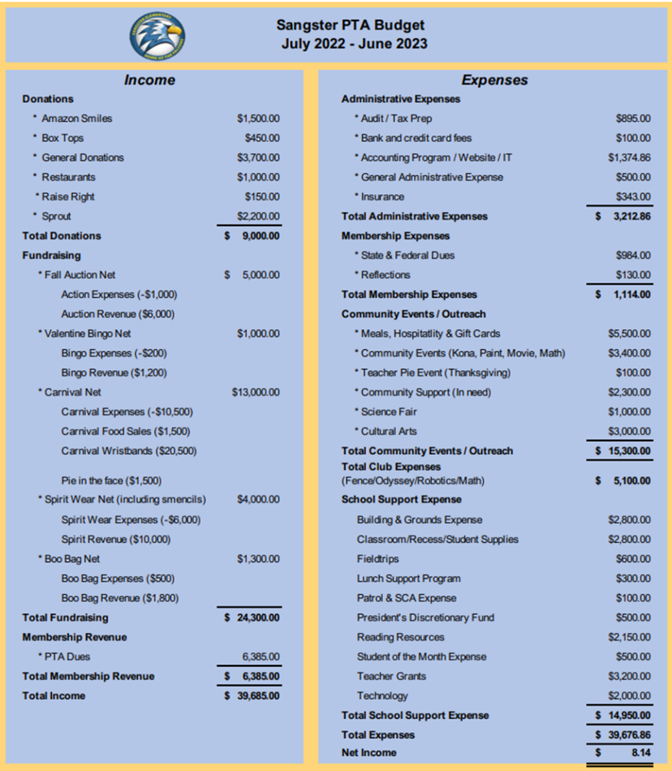
Budget Vote: 22 in favor. Budget passed
- PTA Fundraising: Keri-Marie Cantone
  - Box Tops, Amazon Smiles, Scrip/RaiseRight: Sign up and shop to give back to our scholl with purchases that you would already be making.
- Upcoming Activities
  - Spirit wear
    - Online order(only) due September 30th
    - 3-4 weeks for order arrival
    - https://sangster22.itemorer.com
  - Movie Night
    - September 30th from 6-9:30pm
    - Lightyear will be showing at 7:30pm
    - Food trucks, concessions and Sangster rocks pick up
  - Sangster Rocks
    - Supply pick-up at the conclusion of movie night
    - First come, first serve
    - Return completed rocks by Oct 31st to grey pots behind the library
  - Fall Online Auction
    - November 9-13th
    - Donations tax deductible
    - Looking for donations! Season tickets, craft, business and company merchandise
    - Contact Sally-Anne at Auction@SangsterPTA.org
  - Pyramid Challenge Fun Run
    - November 12 from 10am – 12pm
    - Held at Irving Middle School
    - Details and Registration coming soon.
Clubs Update:
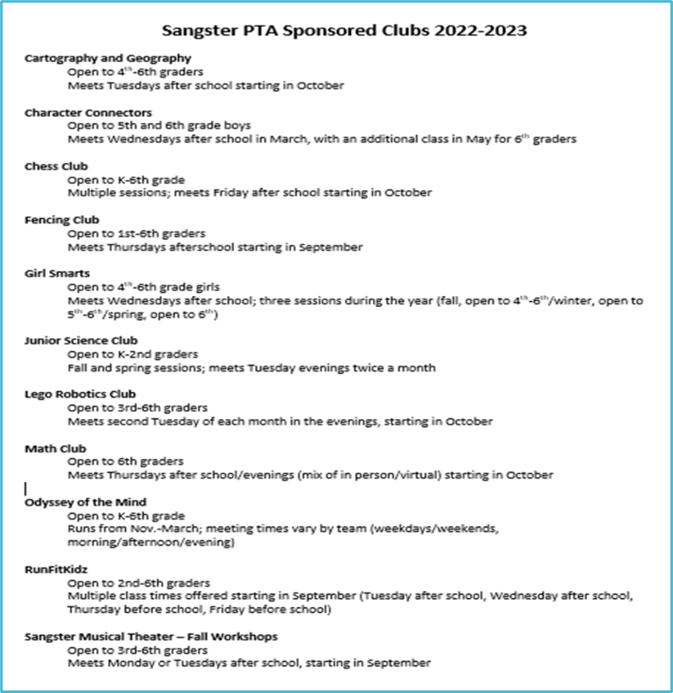
- Call for volunteers
  - Email our Volunteer Coordinator Jill Mitchell at Volunteers@SangsterPTA.org

- OPEN PTA COMMITTEE/EVENT POSITIONS:
- PTA Display
- Movie Night Coordinator
- Email Erin at President@SangsterPTA.org if you are interested in these positions

Meeting adjourned at 7:42pm

