Sangster PTA Meeting Minutes October 13, 2022
Attendance: 19 Called to order at 7:01
Opening Comments: Erin Straub
Principal Update: Ms. Jankovich
What’s new and/or good
- PTA-purchased griddles and waffle makers that were used Oct 10 during equity training to serve the entire staff.
- Lake Braddock feeder-school night- Oct 18th at 6:30pm. Students admitted free with ticket emailed out on Oct. 12th.
Transportation/dismissal updates
- Please limit changes to transportation during the school week. Help your child learn their schedule if their dismissal changes.
Hearing and vision screenings
- All students K-3 will be screened. You will be notified of a vision test failure. A hearing test failure will result in a re-screen in 6 weeks. You will be notified after a second failure.
Health Room updates
- Keep your child home if they are sick. There has been an increase in the number of students coming to school who are on medication. Often the medication wears off, resulting in early pick-up.
Parent/Teacher conference
- Every parent should attend a Parent/Teacher conference. Please reach out to your child’s teacher if you have not yet scheduled a conference.
Room parents
- All classrooms have a room parent. Room parents may reach out for donations which are 100% optional. Room parents should only be contacting you with classroom-related topics.
Military and new family coffee
- Monday Oct. 17th 930-1030am facilitated by Stacy Husiman, Family Liaison.
Veterans’ Day celebration
- Thursday Nov. 10th, 930am. Outdoor ceremony in the bus loop with 6th graders, staff, special guests, handbells, and 5th/6th grade chorus in attendance. Ceremony will be live-streamed into all other classrooms. Military guest speakers will visit classrooms.
September Meeting minute review: Approved with majority in favor, 12 of 18 members present.
Treasury Report by Tiffany Bares: Approved with majority in favor, 11 of 18 members present.
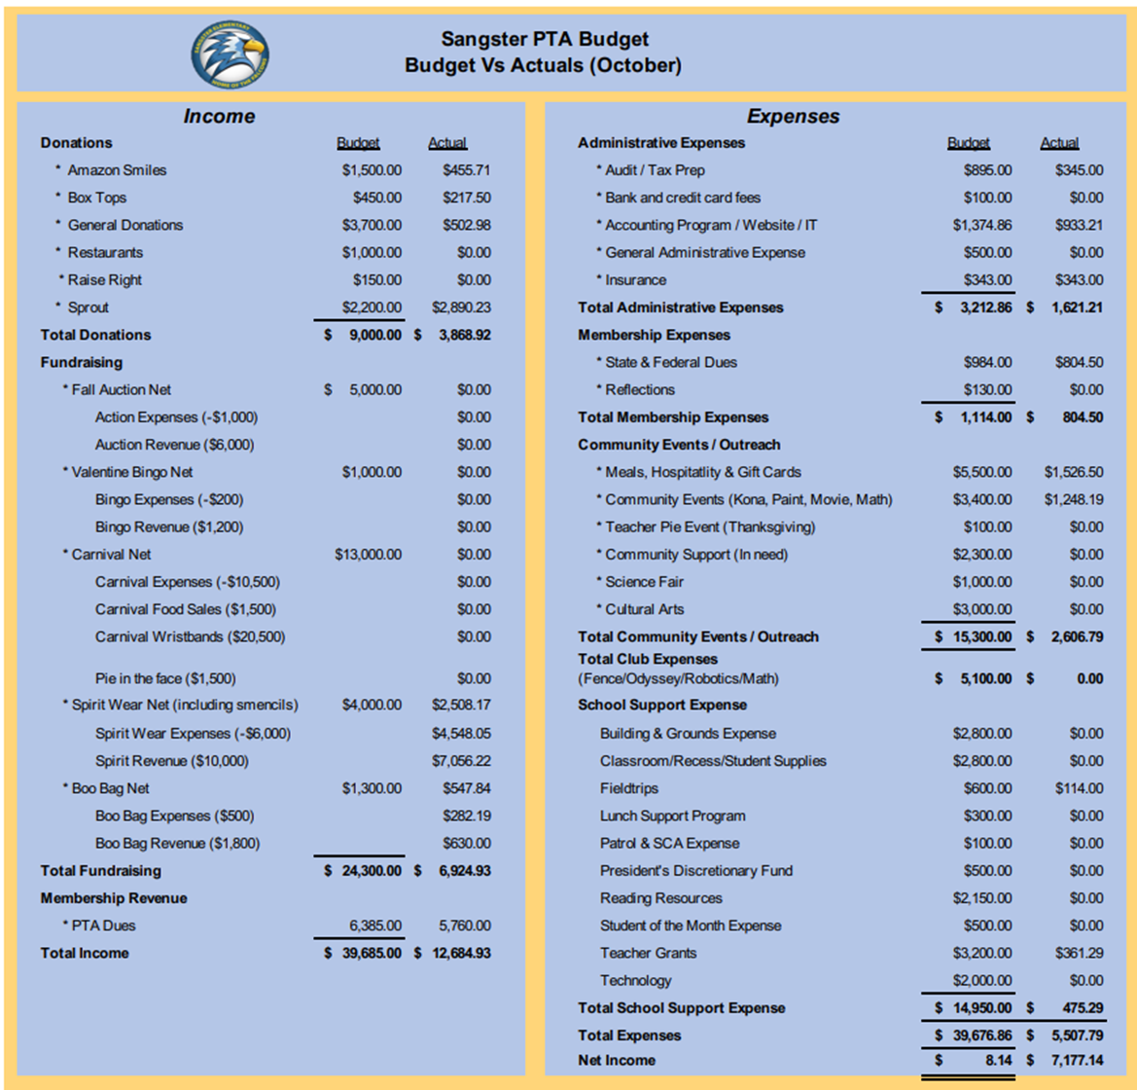
Sangster rocks
- Please return rocks by Oct. 31 to grey pots at the back of the school, directly behind the library. Teachers and office staff would be happy to help direct students to the drop off location.
Sangster dinner and movie night
- Friday Oct. 21st, 6-930pm. Food trucks in the bus loop, movie in the field. Students must be chaperoned at all times. Concession and spirit-wear sales will begin at 6:30am. Lightyear the movie will start on the field at 7pm.
West Springfield pyramid challenge
- Saturday Nov. 12th, at Washington Irving Middle school. Free fun run introducing cross country running and encouraging community involvement in school spirit. Registration closed on 21 Oct.
Boo bags
- $10 bags sold on member hub until Oct 21st. Pickup will be Oct 24-25 from 430-630pm in the Sangster bus loop. All proceeds to Sangster PTA community events.
Fall Auction
- Nov. 9-13 online. Sally-Anne is still looking for donations. Please contact her at auction@sangsterpta.org
- Fliers will go out in Thursday Folders along with messages on FaceBook and NYC starting early November.
Book fair
- Nov 1-4. More information coming next week. Ms. Jankovich shared that Book Fair is trying to coordinate with Math Night to be open one or both nights for shopping. This is not confirmed yet. More information to come.
Thanksgiving pies for teachers
- A link will be available on member hub Nov 1-15, to donate $10 toward pies for our teachers. Pies will be handed out to teachers and staff on Nov. 21 with a donor list.
PTA-sponsored clubs
- Club reminders- Student-parent responsibility to remember which days they have club meeting. All questions, including club schedules need to be directed to Jondrea Crawford, club coordinator.
- The office does not have a list of exact dates for each club meeting.
Volunteers needed
- Committee/Event Positions
  - Movie night coordinator
    - Please email Erin at president@sangsterpta.org if you are interested.
- Interested in volunteering? Email our volunteer coordinator Jill Mitchell, at volunteers@sangsterpta.org

Meeting Adjourned at 7:27pm

