Sangster PTA Meeting Minutes November 17, 2022
Attendance: 16 Called to order at 7:01pm
Opening Comments: Erin Straub
Principal Updates: Allison Jankovich
What’s New and/or Good:
Math Night, Book Fair, Veterans Day Ceremony and Classroom Visits, Fun Run, Movie Night
Strategic Plan
  - FCPS wants to make all schools better and ensure we are all moving in the right direction together. The last Strategic Plan was created five years ago. A lot of things have changed since then. It is time for us to set a new direction based on where FCPS is now. Developing the strategic plan requires feedback from our students and staff on what is going well in school and what are the areas where they feel improvements can be made.
    - Focus right now is students in grades 3 – 12
    - Student administered survey (Grades 3 – 6)
    - Principal-Led Forum (15 – 20 students in Grades 3 – 6)
Friday, November 11th Staff Development Day
  - Science of Reading is the focus - Word study (phonics, phonemic awareness, morphology)
  - Met to discuss skills-based, small group instruction in every grade, K – 6
Lost and Found
  - Friday, November 18th, Monday, November 21st, and Tuesday, November 22nd: Lost and Found items will be outside from 7:30am – 6:30pm
  - Starting in January we will donate lost all found items at the end of the month (February 1st). Teachers and students will have MANY reminders to check the lost and found throughout the month.
  - Posts to be included on Facebook page as reminders.
Family Life and Education (FLE)
  - All students in grades K – 6 participate in socio-emotional lessons, taught by the classroom teacher (Spring)
  - Students in grades 4 – 6 will also participate in Human Growth and Development Lesson (HGD).
    - 4th Grade – 1 Lesson
    - 5th/6th – 5 lessons
  - Parents can opt students out of one or all lessons.
  - Virtual Parent Preview Night on Thursday, December 1st for all grades. Grade level links to be sent out via Allison to all parents.
    - K – 3 from 6:30PM – 7:00PM
    - 4 – 6 from 7:00PM – 7:30PM
AAP Referrals: Jennifer Redford
As mentioned in NYC, AAP referrals are due by Dec 15th. All referrals need to be submitted to Ms. Reford, Ms. Fant and Ms. Biberaj.

Meeting Minutes Review and Vote: Approved with majority vote, 13/16
Treasurers Report: Tiffany Bares
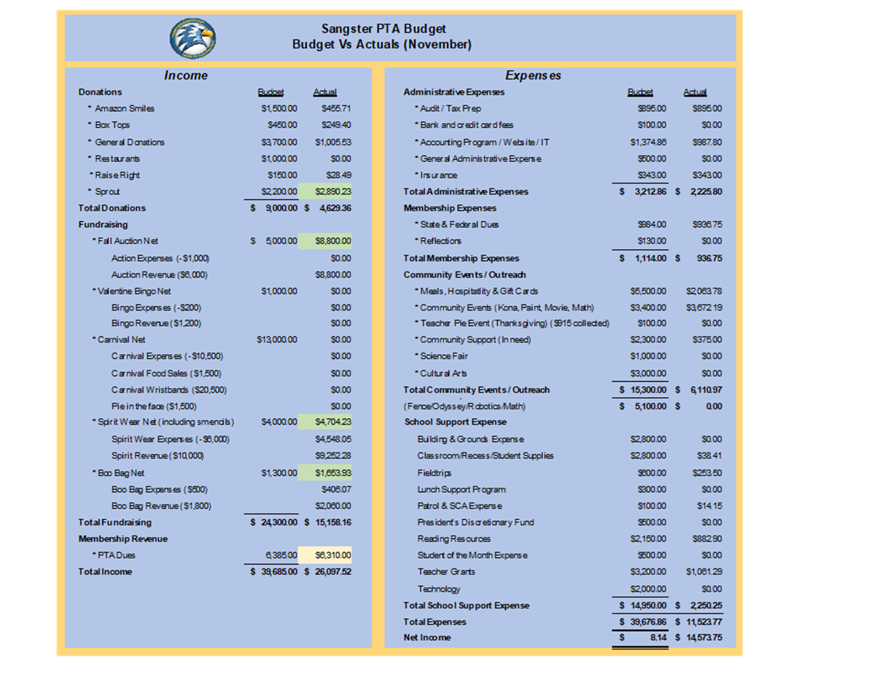
Approved with majority vote: 10/16
PTA BUDGET AMENDMENTS:
- Increase Meals, Hospitality & Gift Cards line item by $2,200 to account for teacher holiday gifts, increased hospitality events and increased food cost.
- Increase Community Events line item by $1,000 to account for donations and increased material/event cost.
- Increase Spirit Wear Expenses line item by $3,000 to replenish inventory and to account for increased material cost.
Approved with majority vote: 9/15
Activities
Fall Auction
Raised almost $8,800! Thank you, Sally-Anne, for all of your hard work.
Pies for Teachers
Pies have been ordered to be gifted to all teachers and staff. Gift cards for pies will be given to bus drivers this year so that they do not have issues with taking their pie on a bus.
Spirit Wear Pop-up Sale:
December 7th at the General Membership in person meeting.
INTERESTED IN VOLUNTEERING?
Email our Volunteer Coordinator Jill Mitchell at Volunteers@SangsterPTA.org

OPEN PTA COMMITTEE/EVENT POSITIONS:
Valentine’s Day BINGO Coordinator
Email Erin at President@SangsterPTA.org if you are interested in these positions
Next Meeting will be held in person on Wednesday, December 7th @ 7pm in the Sangster Library.
Meeting adjourned at 7:26pm

