Sangster PTA Meeting Minutes December 7, 2022
Attendance: 10 Called to order at 7:04pm
- Opening Comments: Erin Straub
- Principal Updates: Allison Jankovich
  - Spirit Week: December 12-16
  - Testing windows:
    - iReady winter window based upon Fall performance for select students only.
    - VGA- Grades 3-6 in January
    - Iowa- 6th grade for advanced math in January
  - Performances
    - Strings
    - LB Children’s Concert
    - LB Pyramid Chorus Concert
  - Balloons Over Broadway Spotlight
    - Video on twitter was highlighted by FCPS.
  - Hour of Code/ Computer Science
    - All grades participate
    - Stem Survey FCPS
    - Erin Gayzik- Wixie Tech for Learning Innovator/Education
  - SCA- Food drive and care packages
  - FLE starting for grades 4-6.
- Meeting Minutes Review and Vote
  - Approved with majority in favor.
- Treasurers Report: Tiffany Bares
  - Approved with majority in favor.
  - 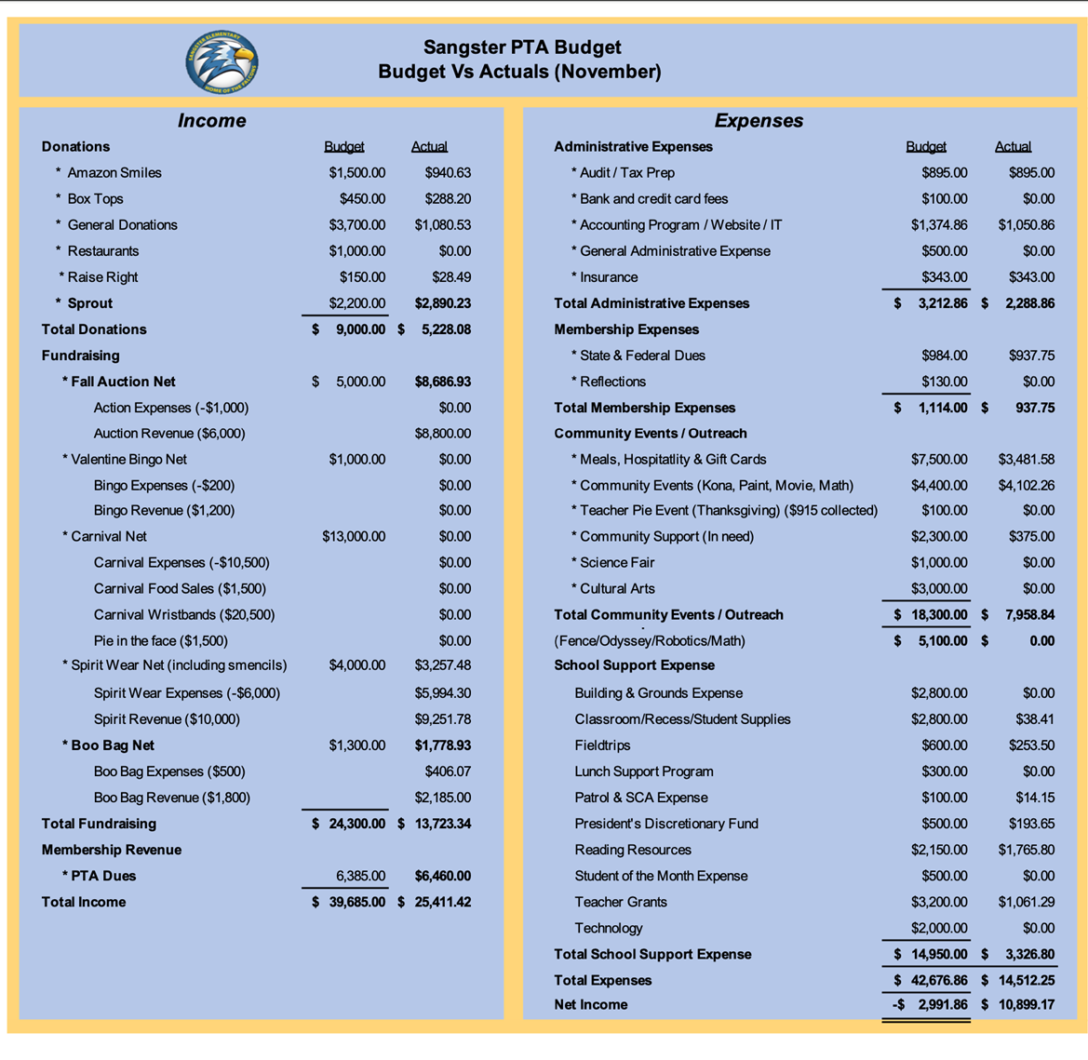
  - 2021 Tax Audit Report Presentation and Vote
    - Approved with majority in favor.

- Upcoming Activities
  - Monday, February 13: Valentine’s Day Bingo
    - In person event held in the cafeteria with pizza dinner.
  - March 25: Odyssey Regional Competition
  - Week of March 27: Science Fair
  - April 26-28: Madagascar Musical Theater
  - Wednesday, May 3: Reflections Ceremony
  - Friday, May 5: Carnival
  - Friday, May 19- Dinner & Movie Night
- Online Directory Available
  - PTA members can access the directory through MemberHub: https://sangster.memberhub.com/directory
  - Those who have opted out are not included in the directory.
  - Class and grade level hubs have been set up.
  - Anyone can modify their own settings through MemberHub.
  - Questions? Contact Margaret Lifsey @ directory@sangsterpta.org
- Call for volunteers
  - INTERESTED IN VOLUNTEERING?
    - Email our Volunteer Coordinator Jill Mitchell at Volunteers@SangsterPTA.org

  - OPEN PTA COMMITTEE/EVENT POSITIONS:
    - Valentine’s Day BINGO Coordinator
    - Email Erin at President@SangsterPTA.org if you are interested in these positions
- Questions
  - When will yearbooks go on sale?
  - When will science fair information be sent home?
    - After the winter break.
- Next meeting will be held January 12th, 2023 virtually.
Meeting adjourned at 7:25pm

