Sangster Elementary PTA Meeting Minutes February 9, 2023
Meeting called to order at 7:01pm Attendance: 18
Opening Comments: Erin Straub
Principal Updates: Allison Jankovich
- Report Cards went out on Thursday. Questions? Reach out to your child’s teacher.
- Principal Coffee on Tues, Feb 21st from 9:30am – 10:30am in the library. Sangster Admin and the Clinical Team will be present for questions and answers.
- Congratulations to Sangster’s MATHCOUNTS team!! Our team of Sarah Shin, Adam Wu, Hyunseo Lee, and George Tedla have earned a first-place finish at the George Washington Chapter Competition. They are now advancing to the MATHCOUNTS state championship on March 4th. First time Sangster has a team going to the state championship.
- Friday, February 10th is a Spirit Day! Students and staff should wear the colors or the shirt/jersey of their favorite team!
- Strategic Plan Community Forums - Community Forums will provide families, students, staff, and community members with an opportunity to participate in and influence the direction of FCPS’ new Strategic Plan.
- Thursday, February 2, 6:30-8 p.m., at Mason Crest Elementary School.
- Saturday, February 4, 9-10:30 a.m., at Spring Hill Elementary School.
- Monday, February 6, 6:30-8 p.m., at Edison High School.
- Tuesday, February 7, 6:30-8 p.m., at South County High School.
- Wednesday, February 8, 6-7:30 p.m., in Spanish, virtual.
- Thursday, February 9, Noon-1:30 p.m., virtual.
- Saturday, February 11, 9-10:30 a.m., virtual.
- Wednesday, February 15, 6:30-8 p.m., at West Springfield High School.
- Thursday, February 16, 6:30-8 p.m., at Hunters Woods Elementary School.
- Read Across America Week begins the week of February 22nd. We will be sending home more information soon along with spirit day calendar.
- The Naglieri Nonverbal Ability Test (NNAT3) will be administered to all 1st grade students (and new to the county students) one day in March. Mrs. Redford will communicate out a date and more information soon.
- 6th Grade promotion date is TBD. The ceremony will take place at Lake Braddock due to the size of the promoting class and their expected guest turnout.
Meeting Minutes Review and Vote:
Approved with all in favor.
Treasurers Report: Tiffany Bares
Approved with majority in favor 16/18
AmazonSmile will be ending so we will fall short of our projected fundraising in that line.
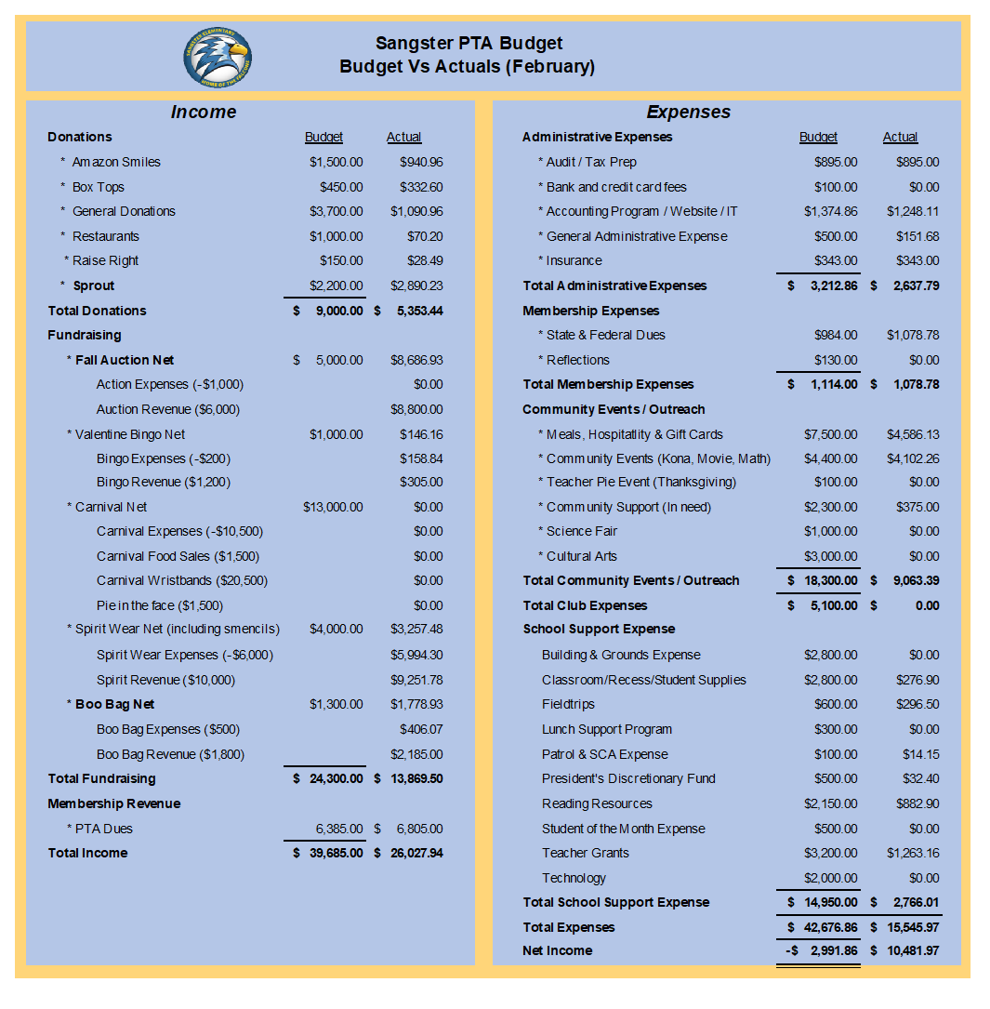
Upcoming PTA Events Summary
- Monday, February 13th, 6-8pm: Valentine’s Bingo
  - Buy tickets on Memberhub. Family Ticket pack $20, Individual ticket $5. Pizza, spirit wear and concessions will be available for purchase.
  - Tuesday, February 21st, 9:30-10:30: Parent Coffee sponsored by the PTA
  - Tuesday, February 21st: Restaurant Fundraiser at Villa Bella
    - Dine-in or carry out.
  - Saturday, March 25: Odyssey Regional Competition
  - Tuesday, March 28- Thursday, March 30: Science Fair
    - Fliers coming home in Thursday folders.
  - Wednesday, April 26-Friday, April 28: Madagascar Musical Theater
  - Wednesday, May 3: Reflections Ceremony
  - Friday, May 5th: Carnival
  - Friday, May 19th: Dinner and Movie Night
Clubs
  - New club! Character Connectors for boys grades 5 and 6. This club will run through March. In May there will be a Q&A with middle school alum.
  - Registration for RunFitKidz will open February 13th.
Call for volunteers!
PTA Volunteer Coordinator (next school year) — Our current coordinator's youngest is in 6th so we really need someone to take over this vital role!
Sangster PTA Secretary (next school year) — This is an essential position so we cannot continue our PTA without it. New Executive Board members will be voted in before the end of the school year.

INTERESTED IN VOLUNTEERING?
Email our Volunteer Coordinator Jill Mitchell at Volunteers@SangsterPTA.org

Email Erin at President@SangsterPTA.org if you are interested in these positions.
Q&A
Q: Can the PTA purchase a cabinet for the Kiss & Ride to store their signs and umbrellas?
A: The PTA will investigate spending some of the grounds and maintenance funds. Please keep the ideas coming. Reach out to Allison Jankovich or Erin Straub.
Meeting Adjourned at 7:36pm

