Sangster Elementary PTA Meeting Minutes March 9, 2023
Call to order at 7:00pm Attendance: 15
Opening Comments: Erin Straub
Principal Updates: Allison Jankovich
- Congratulations to Karen Kleiber, AP for winning the Lake Braddock Pyramid Outstanding Leader Award. Next up – the Region Awards
- School Planning Day on March 3rd – Technology Updates, Importance of Morning Meeting/Closing Circle, Strategic Plan, Conflict Resolution/School Improvement Plan Wellness Goal
- Kindergarten Orientation on March 29th at 6:30PM, you do not have to preregister to attend this event. Please spread the word.
- Jackie Baylow has been promoted! The hiring process for a new registrar is in progress.
- 6th Grade Promotion Ceremony – Will be in June, in the evening, at Lake Braddock Secondary School. Stay Tune for Date/Time
- Clubs and Candid Pictures Rescheduled for Friday, March 17th
- Testing Updates:
  - SOLs: Grades 3-6 testing window will be in May. The schedule impacts the entire schools schedule, not just those who will be taking the test.
  - SEL Screener, iReady, VGA Parent Reports: Questions can be sent to Ms Redford, Ms Kleiber or your student’s teacher.
- April is Month of the Military Child, with Purple-Up Day being April 19th. We will have a school Spirit Week April 17th – 20th. Stay tuned for more details.
- Staffing for 2023 – 2024: Updates will be given as staff turns in their intention forms for the next school year.
- Parent Input
Meeting Minutes Review and Vote approved with 11 of 13 in favor.
Treasurers Report: Tiffany Bares
Vote approved with 10 of 13 in favor.
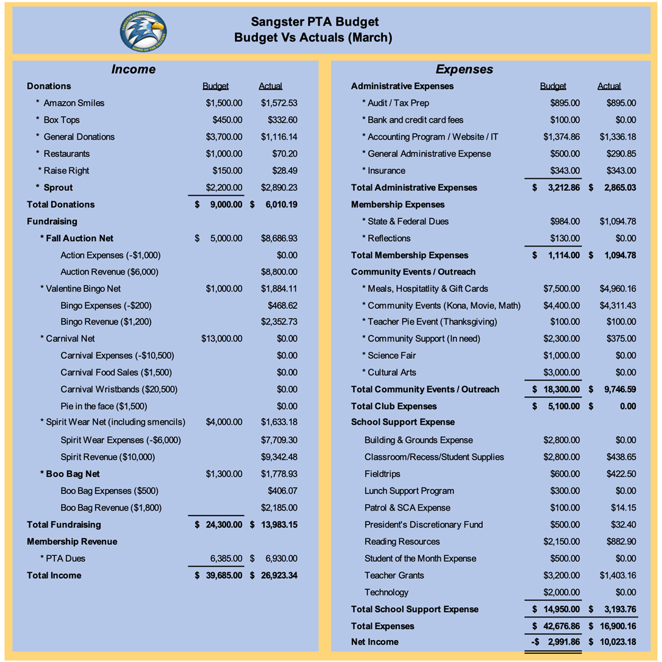
Past Activities:
- Thank you for attending Valentine’s Day Bingo! The PTA raised about $800 over the projected numbers.
- Thank you, Hospitality team, for the breakfast provided during the teacher work day.
Upcoming Activities
- Saturday, March 25: Odyssey Regional Competition
- Tuesday, March 28- Thursday, March 30: Science Fair
  - March 10th was the last day to register projects.
- Wednesday, April 26-Friday, April 28: Madagascar Musical Theater
- Wednesday, May 3: Reflections Ceremony
- Friday, May 5: Carnival
- Friday, May 19: Dinner and Movie Night
- June 13th, Kona Ice event
Other Items:
- Monday, March 13th is the last day to order 6th grade t-shirts.
- RunFit Kidz still has a few openings for Tuesday Morning meetings.
Call for Volunteers!
Vote for Executive Board will be held at the May meeting.
- PTA Volunteer Coordinator (next school year) — coordinate volunteers for PTA events as well as other school events (i.e. Picture Day)
- Cultural Arts Coordinator (next school year) — coordinate Cultural Arts programs for the Sangster community.
- PTA Clubs Coordinator (next school year) — coordinate clubs’ programs for Sangster, complete necessary paperwork and scheduling.
- Sangster PTA Secretary (next school year) — This is an essential position so we cannot continue our PTA without it. New Executive Board members will be voted in before the end of the school year.

INTERESTED IN VOLUNTEERING?
Email our Volunteer Coordinator Jill Mitchell at Volunteers@SangsterPTA.org

Email Erin at President@SangsterPTA.org if you are interested in these positions.
Next meeting will be held April 12th at 7pm.
Meeting adjourned at 7:31pm

