Sangster Elementary PTA Meeting Minutes April 12, 2023
Call to order at 7:00pm Attendance: 17
Opening Comments: Erin Straub
Principal Updates: Allison Jankovich
- Thursday, April 13th – 2 Hour Early Release
- Friday, April 14th – Teacher Workday
- Friday, April 21st – Student/Staff Holiday
- End of 3rd Quarter is April 13th! Report Cards will come home April 27th in Thursday Folders.
- Wednesday, April 19th – Spring and Class Pictures
- End of Year Testing Updates: SOL dates for May were sent home and are also available on the Sangster Website and News You Choose. Window for Spring iReady is now until June. Teacher will schedule testing within their schedules. DSA will also be scheduled by teachers. If you have any questions, please reach out to your child’s teacher, Ms. Redford, or Ms. Klieber.
- April is Month of the Military Child. Spirit week will be April 17-20 with Sangster’s Purple Up day on Wednesday, April 19th. Thank you to Ms. Huisman for organizing the “Walk in my Shoes” art and multiple displays in the hall and cafeteria.
- Coming Up in May:
- Staff Comings and Goings (will share at May PTA meeting)
- Information about class placement requests, prediction of class sizes, and information about Popsicles on the Playground to kick off Back to School.
- Cultural Arts: Jennifer Redford
- Student assembly for grades K-6, sponsored by the PTA, will be held Tuesday April 18th with two sessions:
- Anansegro of Ghana: African Drum, Songs, Stories, and Games
- Musical Theater presents Madagascar. Information will be coming in News You Choose.
Meeting Minutes Review and Vote:
Approved with majority in favor.
Treasurers Report: Tiffany Bares
Approved with majority in favor.
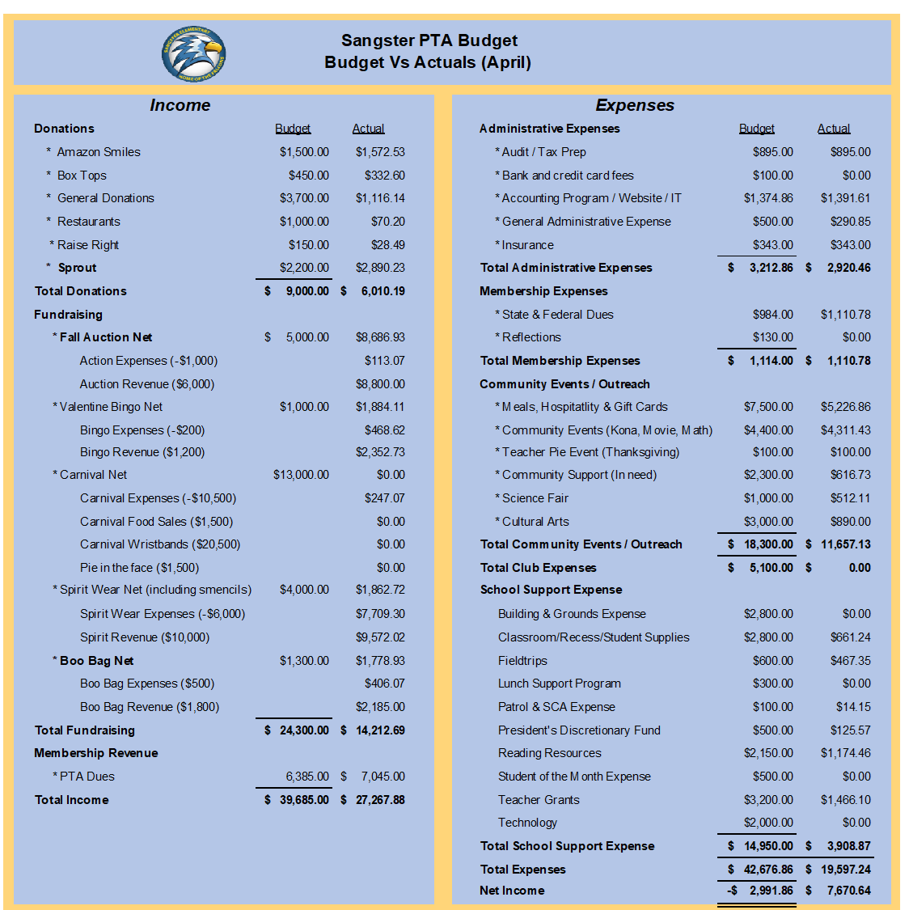
Budget Amendments:
- Increase the Community Events budget by $2,500 to support Kona Ice and other end of year Sangster events.
- Increase the Hospitality Budget by $1500 for End of Year events.
Approved with majority in favor.
Recent Activities:
- Science Fair: Thank you to Sharon Lo for organizing such a fun event!
- Odyssey of the Mind: 5 teams will advance to the State Finals this Saturday. Congratulations to all teams that participated this year and good luck to those that will compete in a few days. Thank you to all of the dedicated coaches, teams and Christina Collins for her leadership role!
Upcoming Activities
- Wednesday, April 26-Friday, April 28: Madagascar Musical Theater
- April 24-28: Clothing Drive Organized by Girl Scout Troop 52006
  - Donations boxes will be in front of Sangster for donations of gently used/like new clothing sizes 4T to adult. *New* unopened packages of socks and underwear will also be accepted. Clothing will be donated to FCPS Title 1 schools that have students in need.
- Wednesday, May 3: Reflections Ceremony
- Friday, May 5: Carnival
  - Adding additional balloon and tattoo artists as requested! There will not be a raffle this year. Pie in the Face already has 4 participants signed up!
  - Presale tickets at $25 each are available for purchase through Memberhub. Children under the age of 3 and chaperones do not need to purchase a ticket.,
  - Please contact Jill Mitchell if you can volunteer to help with Carnival this year.
- Friday, May 19: Dinner and Movie Night
  - Food Trucks: Pizza and Duck Donuts! The movie has not been decided on yet but will be announced soon.
Call for volunteers!
OPEN POSITIONS

Sangster PTA Secretary (next school year) — This is an essential position so we cannot continue our PTA without it. New Executive Board members will be voted in during the May PTA meeting.
*We have had a few people show interest but please feel free to reach out if you would also like information.

INTERESTED IN VOLUNTEERING?
Email our Volunteer Coordinator Jill Mitchell at Volunteers@SangsterPTA.org
Email Erin at President@SangsterPTA.org if you are interested in these positions.

The next meeting will be held in person May 11th, 2023 @ 7pm.

Meeting adjourned at 7:30pm

