Sangster PTA Meeting May 11, 2023
Called to order at 7:02pm Attendance: 15
Opening Comments: Erin Straub
Principal Updates: Allison Jankovich
  - A salad bar is open in the cafeteria for lunch.
  - 6th Grade Promotion
  - Information was sent out via email if you would like special consideration for class placement next year.
  - Yearbooks will be handed out either the second to last day of school or the last day. There will be a few extra yearbooks for sale for in-person sale only. They will not be held on request.
  - Read SOL are complete. Reports/scores will be posted in Parent Vue. An email with instructions will be sent out.
  - Staffing will grow! We are currently allocated 3 Kindergarten teachers and may get a 4th depending on registration. Please register now and spread the word to other families. Grades 1-6 will have 21 general education teachers with the request for 1 more submitted. AAP will have 12 teachers.
Staff comings and goings:
    - Going:
      - Ashley Brand, Elena Dickson, Kim Smith, Kendall Nicely, Megan Grace, June Haywood, Nicole Oberdick (librarian), Cristina McCabe (STEAM), Lisa Crowley, Ms. Dora (Cafeteria Hostess).
    - Coming:
      - New Office Assistant (TBD), Tristan Stutzman (moved to 3rd grade AAP), Bethany Layton, Cristina Hulsopple(5th), Martha Mishkin (STEAM), Librarian (TBA), Cecily Elliot (PHTA), Dani Smedley, Cathy Anderle, Mena Lang.

Meeting Minutes Review and Vote:
Minutes approved with majority in favor (13/15)
Treasurers Report: Tiffany Bares
Report approved with Majority in favor. (14/15)
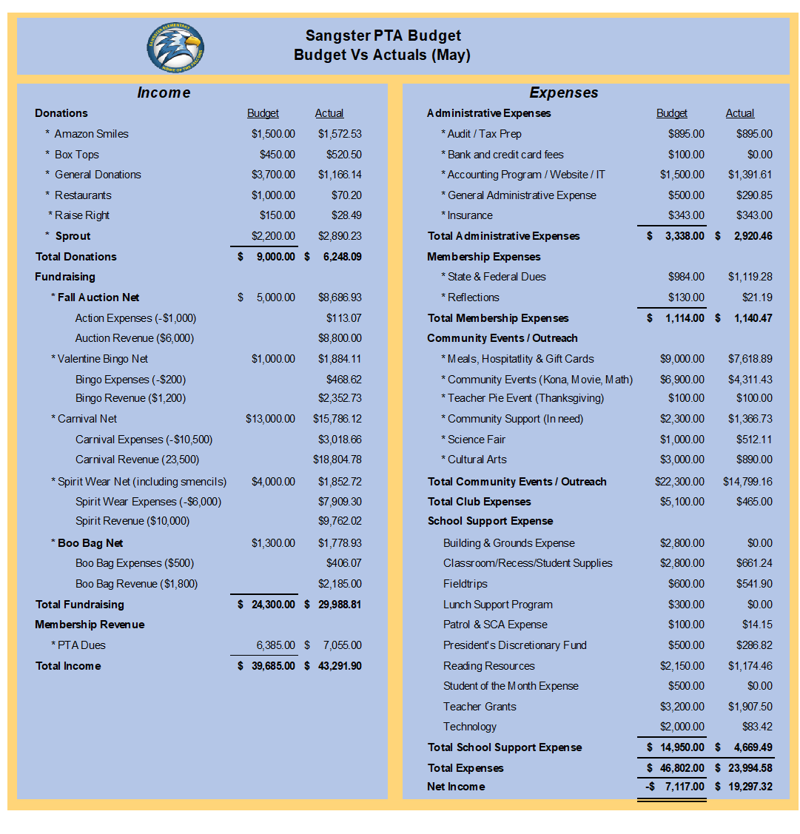

PTA Nominations for SY 2023-2024
Nominations accepted with a vote of 14 in favor.
Recent Activities:
Carnival
- $2,600 raised from Pie in the Face with Mr Zortman a clear winner.
- This year’s Carnival raised around $13, 000 for the PTA.
- Improvements in wait times, volunteer quantity, Pie in the Face visibility, food trucks, and inflatables.
- Request for a tarp on the Pie in the Face stage next year.
Upcoming Activities
Movie Night May 19th
- Pizza sales staring at 6pm ($2 a slice),
- Movie; Minions- Rise of Gru starting at 8pm
- Concessions for sale: candy, popcorn, and drinks
- This is not a drop off event. All minors must be accompanied by an adult at all times.
- Volunteers still needed.
- Play ground will be closed.
Club Updates- Christina Collins
    - Odyssey of the Mind had 2 teams qualify for the World finals. A 5th grade team has accepted and will travel to Michigan to compete. The PTA helped to sponsor this cost.
    - Monica Jaramillo will be taking over the club’s admin next year.
    - Girl smarts/Character Connects will no longer be offered.
    - Cartography will no longer be offered.
Call for volunteers!
Meeting Adjourned at 7:49pm

