2023-2024 SANGSTER REFLECTIONS ENTRY SUBMISSION INFO
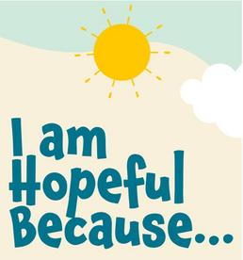
STEP 1: Entrants should reflect on this year's theme - “I AM HOPEFUL BECAUSE…” - and create entries in the art categories of their choice: Dance Choreography, Film Production, Visual Arts, Photography, Music Composition, and Literature.
STEP 2: Entrants should fill out the entry form here with their information and a description of their piece.
STEP 3: Submit your entry form to sangsterptareflections@gmail.com. Entries that are incomplete or not legible will not be accepted. The Reflections Coordinator will confirm receipt, and provide a secure link to Drop Box in order to submit artwork.
STEP 4: Entrants should upload BOTH THEIR ENTRY FORM AND PIECE TO THE DROP BOX as provided via email from the Reflections Coordinator. Fairfax County will only accept electronic artwork!
**NOTE**: Please label entries and forms: student last name.student first name.school.category.age division.artwork title.
For example – Smith.Sal.SangsterElementary.VisualArts.Intermediate.IAmHopefulBecause

