Sangster Elementary PTA Meeting Minutes Date: September 21, 2023

Call to order at 7:00pm Attendance: 21

**Opening Comments: Erin Straub**

**Principal Updates: Allison Jankovich**

**Welcome Back Updates**

* Current Membership: 898 students
* Welcome to Mrs. Mun, 2nd grade teacher, who started on August 28th, 2023. We are fully staffed!
* Congratulations to the teachers and staff of Sangster for being awarded the VDOE Highest Achievement Award due to academic performance from the 2021 – 22 school year. Receiving award next week at school board meeting.
* Back to School Nights: K-3 (Wednesday, Sept 20th) and 4 -6 (Thursday, Sept 28th). No BTSN for Mrs. Lewis’ 4th Grade Class.

**Transportation/Dismissal Updates**

* Sangster Bus 01 – transportation is working on updating the route!
* Kiss-n-Ride and Walkers/Pick-Up – thank you for all of your patience and cooperation! Very smooth start to the year.
* Whenever possible, please try to pick up your students by 3:30PM for appointments.

**Health Room Updates**

* October 26 & 27: Kindergarten hearing and vision screening
* October 23, 25, and 30: 3rd grade hearing and vision screening – 9:30 – 10:50am.

**Upcoming Dates**

* No School on Monday, September 25th in honor of Yom Kippur
* Thursday, September 28th Back to School Night for Grades 4 – 6 from 6:00PM-6:45PM and 7:00PM –7:45PM
* Friday, September 29th: Lake Braddock 50th Anniversary Carnival and Football Game; PTA will be in attendance as well as teachers and students; community welcome.
* Tuesday, October 3rd: AAP Parent Information Night at 7:00PM; the presentation will be shared out.
* Wednesday, October 4th: National Walk to School Day
* Monday, October 9th: School Planning Day – No school for students
* Tuesday, October 10th: PTA Coffee (with Admin) in the Library at 9:30AM
* More updates to share in the next meeting!

**Meeting Minutes Review**

* Review last meeting minutes from May 11th
* No amendments to minutes, approved as written

**Treasurers Report: Tiffany Bares**



* For the 2023/2024 budget, total income of $44,400, expense of $44,320, leaving a balance of $80.
* Changes: We no longer have Amazon Smile as well as Restaurants
* Increases: Expected income of Boo Bags and Membership Revenues
* Expenses: Increase monthly volunteer incentives and an increase in discretionary funds for families in need
* Added club competition expense to provide support
* Added fun run and spelling bee; and pizza for movie night
* Added line item to support military events

**Vote:** Passes with 15/21 in favor

**Recent Activities: Erin Straub**

* Big Thank You
  + Replaced lobby furniture previously
  + The new teacher’s lounge furniture was put together and completed

**Upcoming Activities: Erin Straub**

* Dinner and Movie Night starting at 6PM
  + Concessions and Spirit Wear for Sale
  + If rained out - we will postpone to October 6
  + Notes: playground will be closed during movie
* Rocktober
  + Grab free rocks and paint bag before movie
  + Painted rocks can be placed in the grey pots in front of the school until October 31
* Lake Braddock 50th Anniversary
  + Friday September 29th at 5:30pm-7:30pm
  + Enjoy free admission to carnival
* PTA Coffee
  + October 10th from 9:30-10:30am in the library
* PTA Online Auction
  + November 9-12
  + Contact Sally Anne at [auctionsangster@gmail.com](mailto:auctionsangster@gmail.com) with any questions or donations.

Snapshot shared of upcoming events throughout the year

* NEW: Spelling Bee, Valentine’s Bingo - two sessions, and Fun Run
* Carnival: Friday, May 10th this year

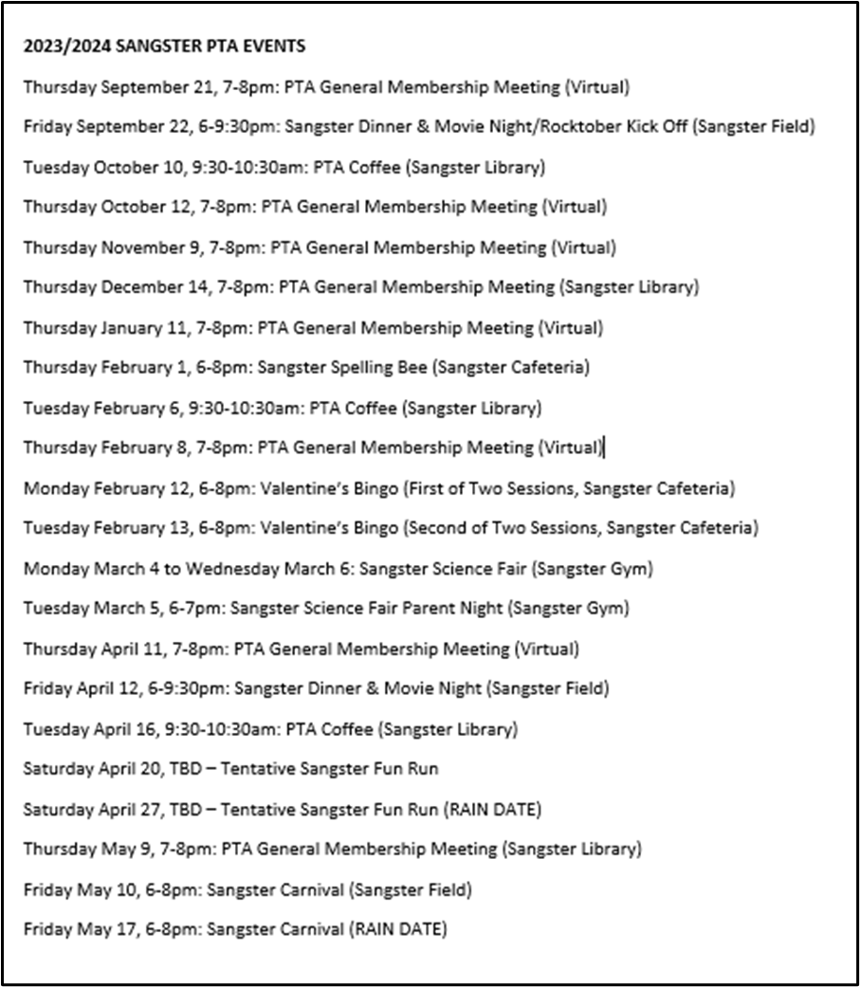

**PTA Clubs: Erin Straub**

* NEW Mindfulness and Yoga (3rd -6th grades)
* Fencing (1st - 6th grades)
* RunFit Kidz (2nd - 6th grades)
* Odyssey of the Mind (All grades)
* Math (6th grade)
* Lego Robotics (3rd - 6th grades)
* Magnus Chess Academy/Chess (All grades)
* Junior Science (K - 2nd grades)
* Musical Theatre - Fall Workshops (3rd - 6th grades)

**Reflections Call for Entries: Danielle Aromando**

* National PTA program where students can be artists and creators
* Theme: I am hopeful because…
* Submissions accepted until Wednesday, November 1st

**Membership Update: Margaret Lifsey**

* Current Membership: 179 members
* MemberHub is now Givebacks
* Membership Directory
  + Will be available in Givebacks late fall
  + Only current PTA members can view the directory
  + Includes information for all Sangster students (PTA members and non-members)
  + There are two ways for parents to opt-out:
    - Submit opt-out form to Sangster office at the beginning of the year
    - Create a profile which allows them to adjust visibility settings
  + By default, the directory includes student/parent names and parent email addresses
  + Additional information may be added by the parent

**Volunteers: Tracy Winward**

* We are always looking for volunteers! If you were on the volunteer list last year and have not signed up for this year PLEASE DO! The list did not roll over.
* The biggest efforts we run for the administration are library volunteers and lunch room volunteers as well as one off items like picture day, field day, etc. We currently have openings for lunch room volunteers, the LBSS pyramid carnival as well as supporting PTA clubs. Opportunities go out first to the email list, then get posted to Facebook.
* Questions? Email Tracy Winward sangsterptavolunteers@gmail.com
* Sign up: Scan QR or visit [https://forms.office.com/r/8NRp9sFfbP](https://na01.safelinks.protection.outlook.com/?url=https%3A%2F%2Fforms.office.com%2Fr%2F8NRp9sFfbP&data=05%7C01%7C%7Ca71d971e8398499cbbe508db9eb11731%7C84df9e7fe9f640afb435aaaaaaaaaaaa%7C1%7C0%7C638278255722993228%7CUnknown%7CTWFpbGZsb3d8eyJWIjoiMC4wLjAwMDAiLCJQIjoiV2luMzIiLCJBTiI6Ik1haWwiLCJXVCI6Mn0%3D%7C3000%7C%7C%7C&sdata=wkC90CxDDVzFLzMUs%2FySG721HGb1Xj5FqLlCWX%2FvPQo%3D&reserved=0)

**Next Meeting**

* The next meeting will be held virtually October 12, 2023 @ 7pm.
* Meeting adjourned at 7:28pm