Sangster Elementary PTA Meeting Minutes Date: October 12, 2023
Call to order at 7:01pm Attendance: 23
Opening Comments: Erin Straub
Principal Updates: Allison Jankovich
- Parent/Teacher Conferences - Teachers will be reaching out soon with information/times for parent teacher conferences. Every parent should attend a parent/teacher conference.
- Room Parents - All classrooms have a Room Parent. Room Parents may be reaching out to you throughout the year to see if you want to donate your time and/or items/snacks for class activities/celebrations. Room Parents should only be contacting you regarding things related to your child’s class. They may ask for a monetary donation as well – which is 100% optional
- Veterans Day
  - Outdoor Ceremony Friday, Nov 10th at 9:30AM in bus loop for students in grades 4 - 6 and guests. The ceremony will be streamed live for students in grades K - 3 in classrooms.
  - Throughout the day, each classroom will invite a Veteran or service member in to share information with students. More details to come from classroom teachers.
- Talking Points
  - One-way communication from school to parents via Talking Points App or via text message. 600 character limit. Ideal for quick reminders.
  - Parent should not reply to the Talking Points message - email. Talking Points does not replace email messages and updates from the teachers.
  - Slow roll - Different grades may be at a different places with implementation.
- School Innovation and Improvement Plan (SIIP)
  - READING: By June 2024, the percentage of Grade 1 - 3 students reading on grade level as measured by the iReady assessment will increase from 88% to 93%.
  - MATH: By the end of the 2023-2024 school year, 100% of students enrolled in advanced math will pass their end of course SOL.
  - Portrait of a Graduate (POG): By June 2024, 100% of students in Grade 5 and 6 will make progress by scoring proficient or advanced on a Sangster-adapted Portrait of a Graduate rubric in the communicator and critical thinker attributes.
Teachers Support our SIIP Goals:
READING
- Explicit reading instruction and targeted interventions (by name and by need).
- Analyze diagnostic and common assessments to target skills.
- Monitor Lexia and ensure usage is appropriate to need
- Increase academic talk between students
MATH
- Understand Math Framework & shift from looking for correct answers towards revealing student thinking
- Increase academic talk between students
POG
- Integrate Portrait of a Graduate attributes and skills in your learning targets and reflection

Impact Aid Form
- We need a form from every parent - both military-connected and not.
- Form will be online through Parent Vue starting October 16th (no paper forms will be coming home)

Testing Updates
- Cognitive Abilities Test (Grades 2 and for select student in grades 3 - 6)
- SEL Screener

Upcoming Dates:
- Thursday, Oct 19th: Wacky Sock Day/Digital Citizenship Week
- Friday, Oct 20th: Field Day
- Tuesday, Oct 31st: Character Dress Up Day
- Friday, Nov 3rd: End of 1st Quarter
- Friday, Nov. 3rd: 2-Hour Early Release
- Monday, Nov. 6th: School Planning Day (no personal leave)
- Tuesday, Nov 7th: Teacher Work Day (No School for Students)
- Thursday, Nov 9th: November Virtual PTA Meeting
- Friday, Nov 10th: Veterans Day Celebration
- Math Nights
  - Tuesday, November 14th: Last names A - L
  - Wednesday, November 15th: Last Names M - Z
- Monday, November 13th - Friday, November 17th: Book Work Book Fair

Meeting Minutes Review and Approve
- Reviewed last meeting minutes from Sept 21
- No responses to question posed on any amendments
- The minutes are approved as written
Treasurer’s Report: Tiffany Bares
- Balanca - $70,801
- Moved the theater account to the operating account to streamline budgeting
- Fundraising: $12,230.77
  - Sprout - $2,991
  - Spiritwear - $2,513
  - Boo Bags - positive $652
  - Membership - 215 members; tracking to the same point as last year
- Expenditures
  - Spent $0 on monthly volunteer drawing
  - Exhausted discretionary funds for families in need, purchased snacks and clothing, field trip expenses, lunches and dinners for sangster staff, pizza for movie night, and registration for spelling bee
  - School Expenses - teacher’s lounge furniture, additional furniture for the school
  - Teacher’s grants - $100 in classroom expenses for 12 teachers
- Motion to accept the financial report: 15 YES

PTA Activities: Erin Straub
- Lake Braddock 50th Anniversary was a success; $85 raised
- Dinner and Movie Night was a success
- New soccer nets installed

- Rocktober
  - Grab free rocks
  - Painted rocks can be placed in the grey pots in front of the school until October 31

- Boo Bags
  - Each bag is $10 and includes glow bracelets, Halloween stationary, Pop Its and of course lots of candy! All the proceeds will go to the Sangster PTA to support community events.
  - Boo Bags can be purchased through MemberHub up until Friday October 20th at 5PM. Pickup will be at the Sangster bus loop on Monday October 23rd and Tuesday October 24th, 4:30pm – 6:30pm.

- Spirit Wear
  - Store open Friday, October 13 to Friday, November 3
  - New merchandise includes sweatpants, tie dye hoodies
  - Items ordered delivered to classroom after Thanksgiving holiday

- West Springfield Pyramid Challenge
  - Saturday, November 11th
  - Registration closes Saturday, October 15

Upcoming PTA Activities
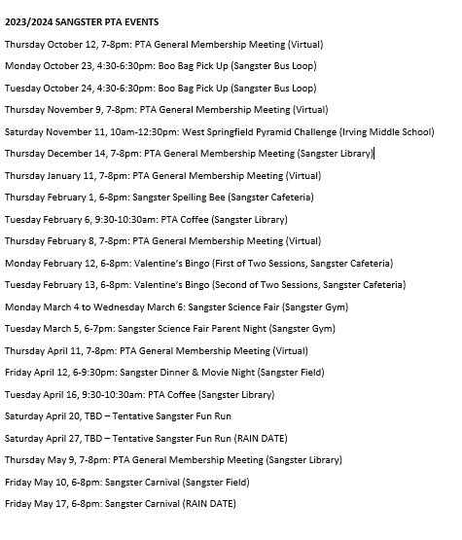
Reflections Call for Entries
- National PTA program where students can be artists and creators
- Theme: I am hopeful because…
- Submissions accepted until Wednesday, November 1st
Sangster Spelling Bee
- Open to 3-6 grade students
- Will be held Thursday, February 1 from 6:00-9:00pm
- Registration open Oct 16-Dec 15
- The winner will compete in the Fairfax County Spelling Bee on March 17; the winner will then compete at the National Scripps Spelling Bee
- Mini Bee for Kindergarten to 2 grade to be held; information forthcoming
Membership Update: Margaret Lifsey
- Current Membership: 215 members
- Membership Directory will be available in Givebacks late fall
Volunteers: Tracy Winward
- We are always looking for volunteers! If you were on the volunteer list last year and have not signed up for this year PLEASE DO! The list did not roll over.
- The biggest efforts we run for the administration are library volunteers and lunch room volunteers as well as one off items like picture day, field day, etc. We currently have openings for lunch room volunteers, the LBSS pyramid carnival as well as supporting PTA clubs. Opportunities go out first to the email list, then get posted to Facebook.
- Questions? Email Tracy Winward sangsterptavolunteers@gmail.com
- Sign up: Scan QR or visit https://forms.office.com/r/8NRp9sFfbP

Next Meeting
- The next meeting will be held virtually November 9, 2023 @ 7pm
- Meeting adjourned at 7:32pm

