Sangster Elementary PTA Meeting Minutes Date: December 14, 2023
Call to order at 7:02pm Attendance: 11
Opening Comments: Erin Straub
- Thank you for being here for one of our two in-person meetings this year.
Principal Updates: Allison Jankovich
Happy Holidays!!
- A lot to celebrate this month! Staff gift drop-off boxes will remain outside through tomorrow and Holiday Assistance for families in need will both go through Friday, Dec 15th. Thank you to Mrs Uhl and multiple current and former Girl Scouts and their parent for creating over 200 bags of food for Sangster students over the break.
Attendance Reminders
- Chronic absenteeism — which is defined as a student missing 10% or more of school for any reason. Family vacations and extended weekends are unexcused absences.
- Data shows that:
  - Missing just 10% of school — just two days a month — negatively affects a student’s academic performance.
  - Only 17% of students who were chronically absent in both kindergarten and first grade were reading proficiently in third grade, compared to 64% of those with good attendance.
Online Sangster Book Fair Open
- SangsterESOnlineBookstore
- Possibility of spring book fair this year
Level IV AAP Referral
- Parent referrals to be considered for Full-Time (Level IV) AAP services for the 2024-2025 school year for current students in grades 2-6 are due no later than Friday, December 15.
- Referrals will not be accepted after the deadline.
- Referral forms must be submitted as an attachment via email and must include both of the following contacts:
  - Linda Biberaj, AART (LBiberaj@fcps.edu) and Jennifer Redford, Assistant Principal, (JARedford@fcps.edu).
  - You will receive an email confirming receipt of your referral.
Sangster Gardens
- Thank you to the PTA for their support and donation to the new outdoor benches
- Thank you to Mrs. MacIver, Mrs. Kleiber, and the newly-formed Eco Club for helping to make our outdoor area enjoyable for all of our students!

Family Cultural Night
- Date TBD (Spring of 2024) Notification will go out!
- Interest survey went out in my Dec 7th Sangster Updates email. Feel free to use that link or email Mrs. Kleiber at KHKleiber@fcps.edu
Meeting Minutes Review and Approve
- Reviewed last meeting minutes from Nov 9
- No responses to question posed on any amendments
- The minutes are approved as written
Treasurer’s Report: Tiffany Bares
- Fundraising: $24,749.16
- Expenditures: $20,570.99
- Motion to accept the financial report accepted with 10 yes

PTA Activities: Erin Straub
Thank you: Thanksgiving Pies, PTA Online Auction, Winter Party Lollipops

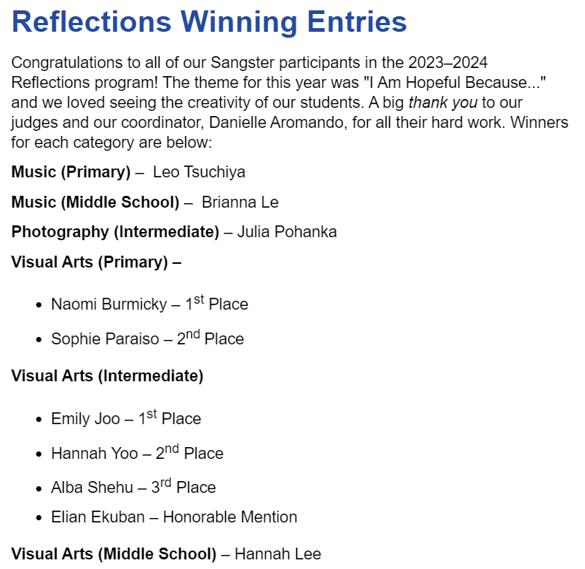

Valentine’s Bingo
- Date: Feb 12 and 13 (families may choose which date to attend)
- Time: 6-8pm (pizza from 6-7, bingo from 7-8)
- All tickets and pizza will be sold ahead of time ($5 per seat - everyone must have a ticket including parents)
- Gretchen Gooding is coordinating
Science Fair
- Date: Feb 27-29
- Participation is optional
- Registration is now open
- Projects should be worked on at home, under parental supervision, independently or with partners.
- Link to register and guidelines: https://bit.ly/4adYuCT.
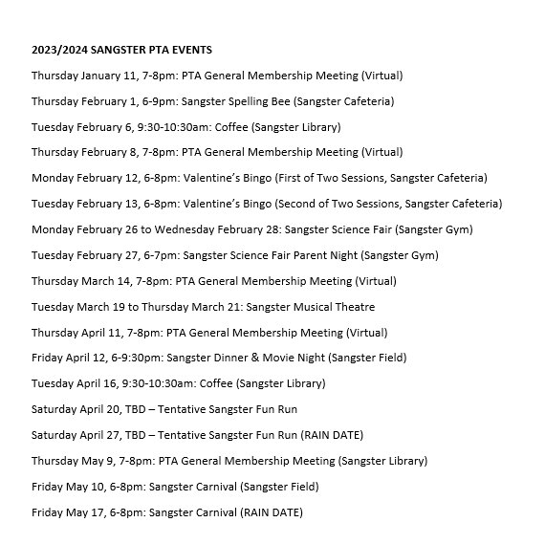
Membership: Margaret Lifsey
- Current members: 238
- School Directory now available at https://sangster.memberhub.com/directory
- For questions contact Margaret Lifsey sangsterptadirectory@gmail.com.
Volunteers: Tracy Winward
- We are always looking for volunteers! To sign up for the volunteer list, please scan the QR code below. Questions? Please email our PTA Volunteer Coordinator, Tracy Winward at sangsterptavolunteers@gmail.com.Sign up: Scan QR or visit https://forms.office.com/r/8NRp9sFfbP
The next meeting will be held virtually on January 11, 2023 @ 7pm.
Meeting adjourned at 7:34pm.

