Sangster Elementary PTA Meeting Minutes Date: January 11, 2023
Call to order at 7:00pm Attendance: 16
Principal Updates: Allison Jankovich
Upcoming Concerts
Bells/Drums/Chorus/Concert on Wed, Jan 24th
- Bells/Drums: 6:30PM - 7:00PM in Café
- Chorus: 7:15PM - 7:45PM in Gym
Band on Feb 6th
- Sangster Cafe at 7PM
End of 2nd Quarter
- Thursday, January 25th.
- 2 Hour Early Release at 1:55PM on Thur, Jan 25th
- Teacher Workday on Friday, January 26th
- Report cards go home Thursday, February 8th

REMINDER - School Innovation and Improvement Plan (SIIP)
- READING: By June 2024, the percentage of Grade 1 - 3 students reading on grade level as measured by the iReady assessment will increase from 88% to 93%.
- MATH: By the end of the 2023-2024 school year, 100% of students enrolled in advanced math will pass their end of course SOL.
- Portrait of a Graduate (POG): By June 2024, 100% of students in Grade 5 and 6 will make progress by scoring proficient or advanced on a Sangster-adapted Portrait of a Graduate rubric in the communicator and critical thinker attributes.

Meeting Minutes Review and Approve
- Reviewed last meeting minutes from Dec 9
- No responses to question posed on any amendments
- The minutes are approved as written
Treasurer’s Report: Tiffany Bares
- Fundraising: $24,749.16
- Expenditures: $20,570.99
- Motion to accept the financial report accepted with 10 yes

PTA Activities: Erin Straub
Spelling Bee
- Please join us on Thursday, February 1 beginning at 6 p.m. in the Sangster cafeteria to cheer on our Spelling Bee participants!
- Volunteers are needed to help run the event - please reach out to Tracy at sangsterptavolunteers@gmail.com to sign up.

Valentine’s Bingo
- Date: Feb 12 and 13 (families may choose which date to attend)
- Time: 6-8pm (pizza from 6-7, bingo from 7-8)
- All tickets and pizza will be sold ahead of time ($5 per seat - everyone must have a ticket including parents)

Science Fair
- Date: Feb 27-29
- Participation is optional
- Registration is now open
- Projects should be worked on at home, under parental supervision, independently or with partners.
- Link to register and guidelines: https://bit.ly/4adYuCT.
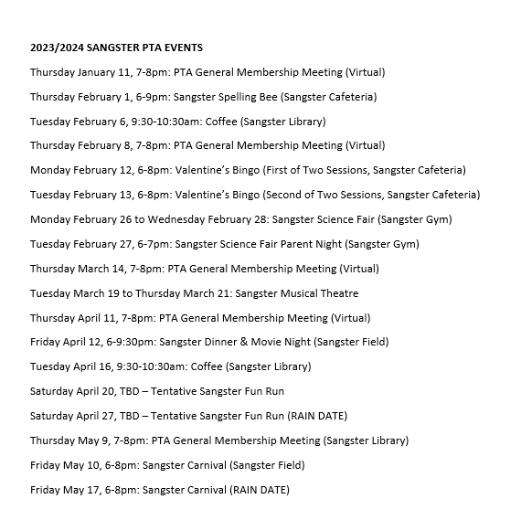
Membership: Margaret Lifsey
- Current members: 242
- School Directory now available at https://sangster.memberhub.com/directory
- For questions contact Margaret Lifsey sangsterptadirectory@gmail.com.
Volunteers: Tracy Winward
- We are always looking for volunteers! To sign up for the volunteer list, please scan the QR code below. Questions? Please email our PTA Volunteer Coordinator, Tracy Winward at sangsterptavolunteers@gmail.com.Sign up: Scan QR or visit https://forms.office.com/r/8NRp9sFfbP
The next meeting will be held virtually on February 8, 2024 @ 7pm.
Meeting adjourned at 7:24pm.

