Sangster Elementary PTA Meeting Minutes Date: January 8, 2023
Call to order at 7:00pm Attendance: 23
Principal Updates: Allison Jankovich
Family Cultural Night on March 13th, 2024, from 6:30PM – 8:00P
Join us in the celebration of the unique heritages, rich cultures, and traditions of our Sangster families! Everyone is welcome to attend as a guest, but there are two ways to share your family’s culture that evening:
- Students are invited to participate in a fashion show and share their cultural dress. Students will walk across the stage and say which culture they are representing.
- Families are invited to share their culture by offering a table display ( e.g., poster, clothing, art, artifacts, flags) with bite-sized food samples (optional).
For our planning purposes, please sign-up if one of these two options is something your family is interested in: http://bit.ly/SESCulturalNight2024
The sign-up is open now and will close on March 1, 2024. Again, all families are invited to attend on March 13th!
General Reminders
- U-Turns on Reservation Dr. are both illegal and very, very dangerous. We continue to get reports of cars making these illegal U-Turns. The safety of our school community is compromised every time someone does this. Please take the time to use Kiss-n-Ride and/or find another route to get back up to the Parkway. Thank you!
- Please remember, if your child arrives after 9:10AM, you must escort them into the main office and sign them in.
- Attendance matters! We want you to keep your child home when they are sick, however, we ask that you please refrain from scheduling trips and other non-essential travel during the school week. Thanks!
- There is still time! Order a Sangster Yearbook at ybpay.com and use Yearbook Code: 13246524. If you have questions, please contact Coretta Britt in the main office at cbritt@fcps.edu
- This year, Ramadan falls from March 11 - April 10, 2024. . We will be offering a space for students to go instead of the cafeteria if they plan to fast. If your child will be fasting, please let your child’s teacher know.
Upcoming Dates
- Monday, February 5th – Friday, February 9th: School Counselors Week
- Friday, February 9th: Sangster Spirit Day – Wear your favorite team jersey for the Super Bowl!
- Monday, February 12th and Tuesday, February 13th: PTA Valentine’s Bingo in the Café. Pre-ordered pizza will be from 6PM – 7PM and Bingo is 7PM – 8PM. Sign up on Member Hub!
- Friday, February 16th: History Alive! Astronaut Sally Ride Cultural Arts Assemblies for students in Grades K – 6.
- Monday, February 19th: No School in celebration of President’s Day
- Thursday, February 22nd: School Bus Driver Appreciation Day
- Tuesday, February 27th: 6th Grade Advanced Math Iowa Algebra Aptitude Test (IAAT)
- Wednesday, February 28th: PTA Science Fair Parent Night
- Tuesday, March 5th: No School for Students – Primary Election Voting Day

Future Upcoming Dates
- Monday, March 25th - Friday, March 29th = Spring Break
- Monday, April 1st = Teacher Workday. No School for Students
- April is Month of the Military Child! Stay tuned for more!
- March 4th - 8th is Read Across America Week
- Tuesday, April 2nd = Staff Development Day. No School for Students.
- Wednesday, April 17th = Kindergarten Orientation from 6:30PM - 7:30PM
- Tuesday, June 11th = 6th Grade Promotion Ceremony at Lake Braddock Secondary School at 6:00PM. More Details to come!
Getting Ready for 2024-2025
- Please let Jackie Fant, registrar, know ASAP if you are planning a move for next year! Let Allison know as well.
- Any new families to the neighborhood over the summer? The sooner they can get into our system - the better! Share Jackie Fants name with all new families! :)
- Teachers are starting to communicate their intentions for next year. I will have an update in May/June about any staffing changes. Also, our staffing information (how many teachers allotted) will also be communicated out in the Spring.
- In April, Allison will send out an email to parents, allowing them to share feedback for next year. There are NO guarantees, even if a written request of a friend or teacher is sent. Parents should focus on strengths and growth areas regarding their children instead - very helpful for teacher matches.

Meeting Minutes Review and Approve
- Reviewed last meeting minutes from Jan 11
- No responses to question posed on any amendments
- The minutes are approved as written
Treasurer’s Report: Tiffany Bares
- Fundraising: $26,282.48
- Expenditures: $23,096.11
- Motion to accept the financial report accepted with 16 yes

PTA Activities: Erin Straub
Spelling Bee
- Congratulations to our Sangster Spelling Bee winners - Katherine Song (1st), Francie Baroang (2nd) and Damian Anderle (3rd)!!

Valentine’s Bingo
- Date: Feb 12 and 13 (families may choose which date to attend)
- Time: 6-8pm (pizza from 6-7, bingo from 7-8)
- All tickets and pizza will be sold ahead of time ($5 per seat - everyone must have a ticket including parents)

Science Fair
- Date: Feb 27-29
- Participation is optional
- Registration is open
- Projects should be worked on at home, under parental supervision, independently or with partners.
- Link to register and guidelines: https://bit.ly/4adYuCT.
West Springfield Pyramid Challenge
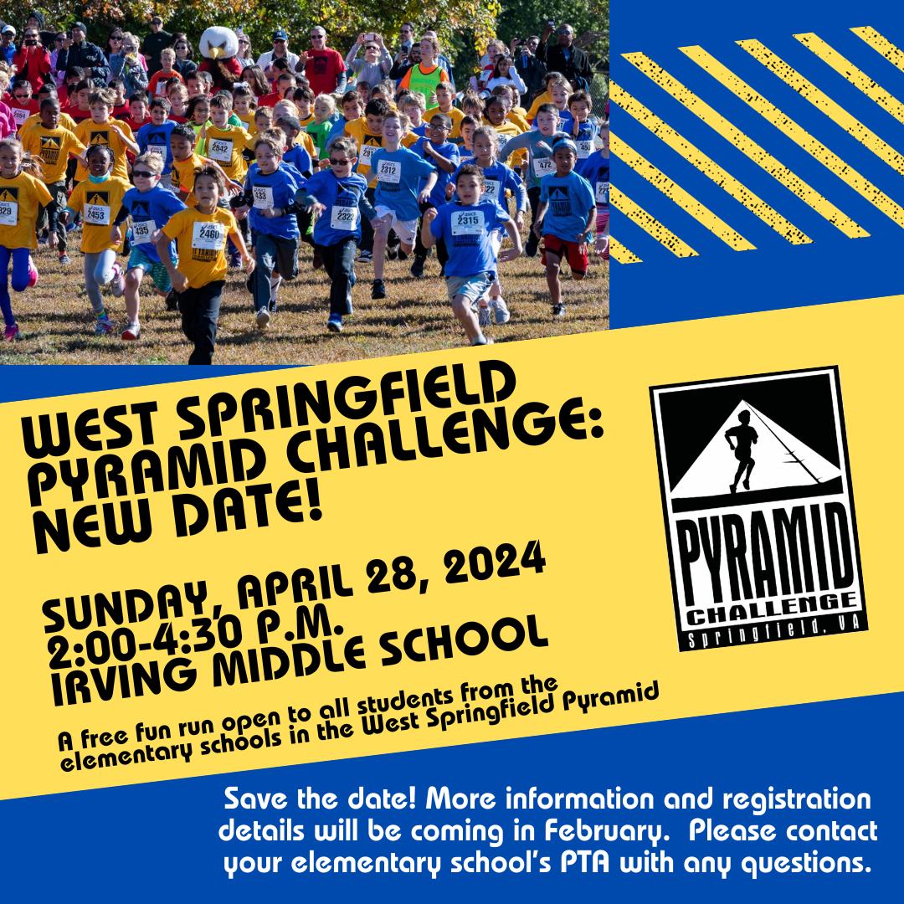
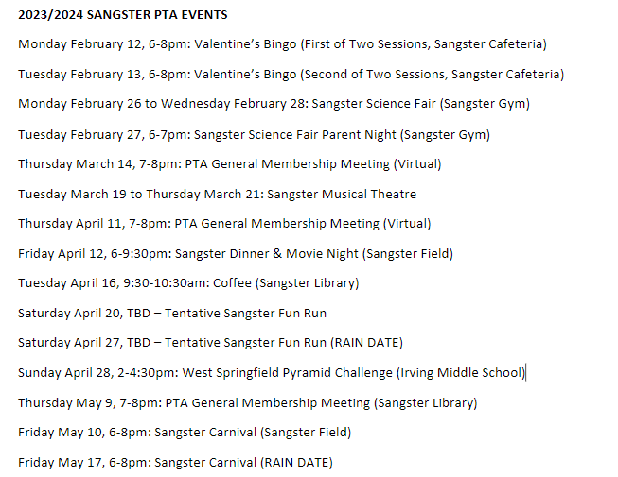
Membership: Margaret Lifsey
- Current members: 250
- School Directory now available at https://sangster.memberhub.com/directory
- For questions contact Margaret Lifsey sangsterptadirectory@gmail.com.
Volunteers: Tracy Winward
- We are always looking for volunteers! To sign up for the volunteer list, please scan the QR code below. Questions? Please email our PTA Volunteer Coordinator, Tracy Winward at sangsterptavolunteers@gmail.com.Sign up: Scan QR or visit https://forms.office.com/r/8NRp9sFfbP
The next meeting will be held virtually on March 14, 2024 @ 7pm.
Meeting adjourned at 7:42pm.

