Sangster Elementary PTA Meeting Minutes Date: March 11, 2023
Call to order at 7:00pm Attendance: 23
Principal Updates: Allison Jankovich
Family Cultural Night took place on March 13th, 2024, from 6:30PM – 8:00P
Families joined us in celebration of the unique heritages, rich cultures, and traditions of our Sangster families!
Thank you to the entire community - students, staff, parents, and families for an amazing night!
Read Across America Week
- March 4th - 8th
- Thank you to Stephanie Oden, Sangster Librarian!
New COVID Protocols
- The COVID-19 isolation period of 5 days is no longer recommended.
- The new respiratory virus guidance applies to respiratory viral illnesses, to include COVID-19, influenza, and respiratory syncytial virus (RSV).
- Students who have symptoms of, tested positive for, or have been diagnosed with, a respiratory virus e.g., COVID-19, influenza, RSV may return to school when:
  - Student is fever-free for 24 hours without fever reducing medication; AND
  - Student’s symptoms have improved or resolved
Spring Picture Day
- Friday, March 15th. All students will get their picture taken as well as class photos.
Visit from Sandy Anderson, Springfield District School Board Member on Friday, March 15th.
Sandy Anderson was sworn into office as the Springfield District School Board Member on December 13, 2023. Anderson is a Northern Virginia native and FCPS graduate herself.
After graduating from Lake Braddock Secondary School, Anderson stayed local and went to George Mason University for her undergraduate degree in English. During her senior year, she met her husband at an ethics conference in upstate New York. Shortly after they both graduated from college, her husband started his military career with Anderson by his side. After spending a decade with several moves and deployments, the couple moved back to Virginia where her husband finished his military career, and the couple started their family.
For much of their time in the military, Anderson taught college English after earning her master’s degree at the University of North Carolina – Greensboro. After 14 years of teaching across multiple states and platforms, Anderson moved into a position supporting two Department of Defense youth programs focusing on both science, technology, engineering, arts/design, and mathematics (STEAM) education for K-12 students and teenagers at risk of not graduating in their traditional high school environments.
Anderson believes strongly in supporting the community where you live. When her children went to school, Anderson saw the opportunity to support the school community and joined the Silverbrook Elementary Parent Teacher Organization Board. She was on the Board for seven years, with five as president. She lives in Fairfax Station with her husband, two boys, and two big dogs.
Principal Survey
On Monday, March 18 Sangster parents/guardians will be sent an email containing a link to complete the online FCPS Principal Evaluation Parent/Guardian Feedback Form. This questionnaire is part of the VDOE-mandated Performance Evaluation Program for principals and offers parents/guardians an opportunity to provide anonymous input about various topics related to our school. These topics include how the principal demonstrates/impacts instructional leadership, school climate, management, communication and community relations, culturally responsive and equitable leadership, and professionalism within the school.
The questionnaire will be administered between March 18 and April 5. When you receive an email from FCPS Surveys, please take a few minutes to complete the questionnaire. Your feedback matters!
Testing Updates
- 5th Grade Integrated Reading/Writing SOL: APril 23rd
- 1st Grade NNAT3: Friday, April 5th, starting at 9:30AM
- Grades 3 - 6 Standards of Learning (SOLS)
  - May 1st = 6th Reading
  - May 7th= 5th Reading
  - May 8th = 4th Reading
  - May 10th = 3rd Reading
  - May 16th = 4th Math
  - May 17th = 5th Math
  - May 20th = 6th Math
  - May 21st = 3rd Math
  - May 22nd = 5th Science
General Reminders/Updates
- U-Turns and reckless driving CONTINUE TO BE both illegal and very, very dangerous. Please use caution and follow all traffic laws when dropping off or picking your child up.
- Attendance matters! We want you to keep your child home when they are sick, however, we ask that you please refrain from scheduling trips and other non-essential travel during the school week. Thanks!
- Staffing Updates for Next Year:
  - Projected around 925 (right now 894)
  - Projected for 3 Kindergarten Classes for 2024-25
  - Same number of General Ed and AAP Teachers as we have now (Everything is subject to change based on enrollment as we get closer to the start of school. Also,it’s hard to predict how many classes at each grade level at this point).
  - In April/May we will let you know any staff that are not returning or any new hires we have at that point.

Upcoming Dates
- Tuesday, March 19th – Thursday, March 21st: Sangster PTA Musical Theater production of Willy Wonka Jr at 7:00PM. Be on the lookout for ticket information in News You Choose and in Thursday Folders.
- Friday, March 22nd = End of 3rd Quarter
- Monday, March 25th – Friday, March 29th: Spring Break
- Monday, April 1st: Teacher Workday (No School for Students)
- Tuesday, April 2nd: Staff Development Day (No School for Students)
- Friday, April 5th = NNAT3 Testing for 1st Grade
- Wednesday, April 10th: No School in honor of Ead al-Fitr
- Thursday, April 11th: Virtual PTA Meeting at 7:00PM
- Friday, April 12th: PTA Dinner and Movie Night (details coming out soon)
- Wednesday, April 17th: Kindergarten Orientation at 6:30PM for rising Kindergarten students and parents.
- Monday, May 6th - 10th: Teacher Appreciation
- Tuesday, June 11th - 6th Grade Promotion at Lake Braddock at 6:00PM. More details to follow…

All performances of Sangster Musical Theatre's Willy Wonka Jr., March 19–21, have completely sold out! If you are interested in putting your name on a waitlist, please complete this Google Form.

Meeting Minutes Review and Approve
- Reviewed last meeting minutes from Feb 8
- No responses to question posed on any amendments
- The minutes are approved as written
Treasurer’s Report: Tiffany Bares
- Fundraising: $26,609.14
- Expenditures: $24,357.39
- Motion to accept the financial report accepted with 21 yes

PTA Activities: Erin Straub
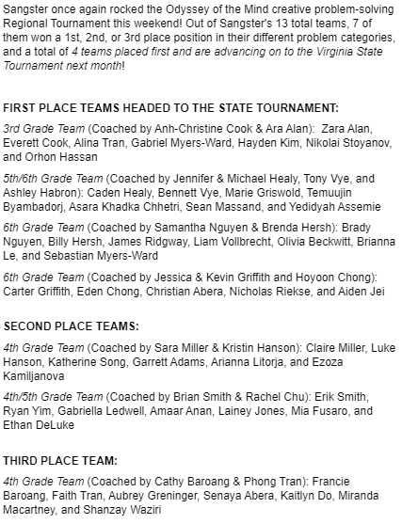
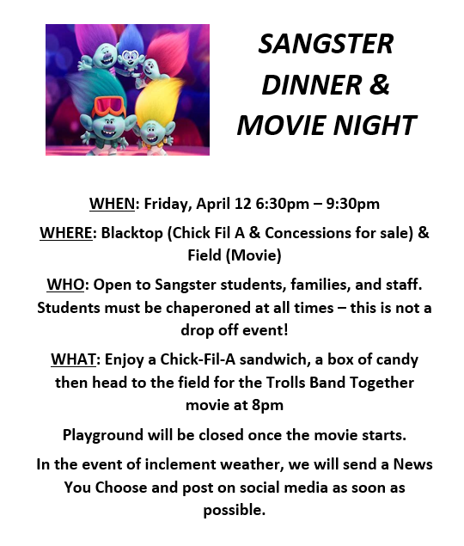
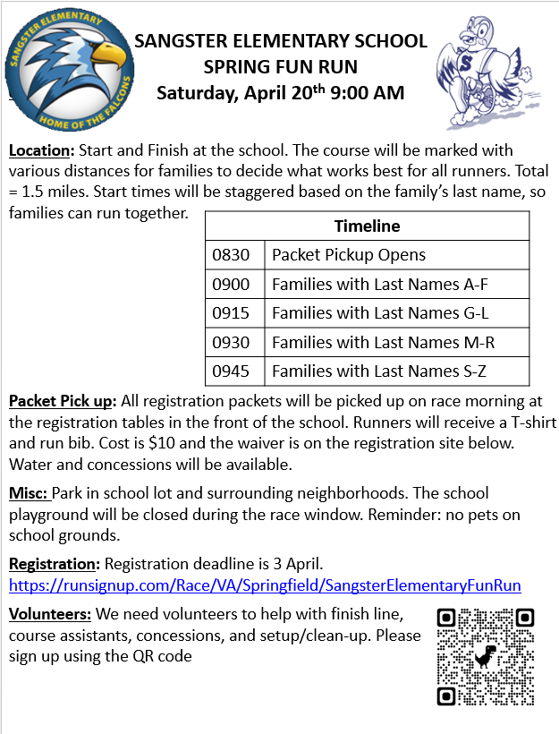
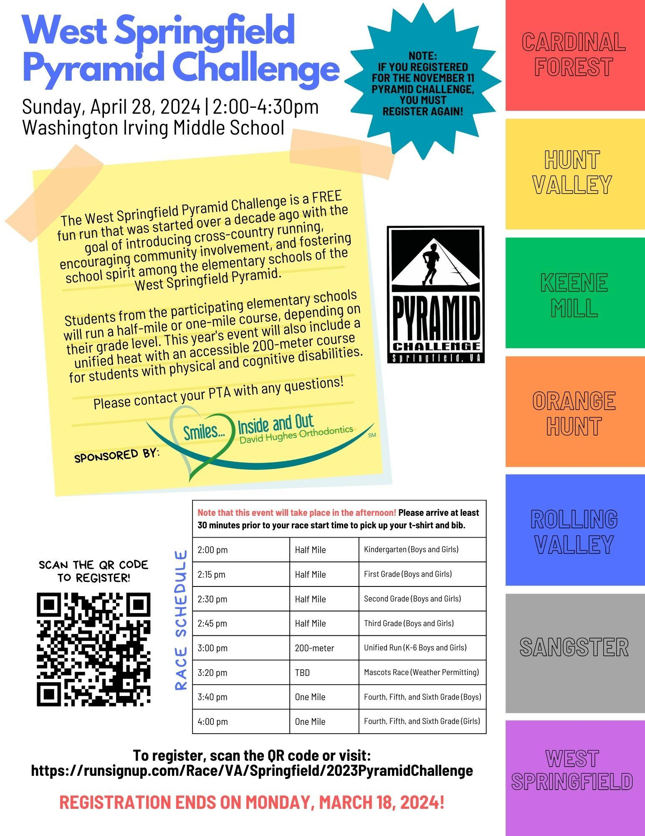
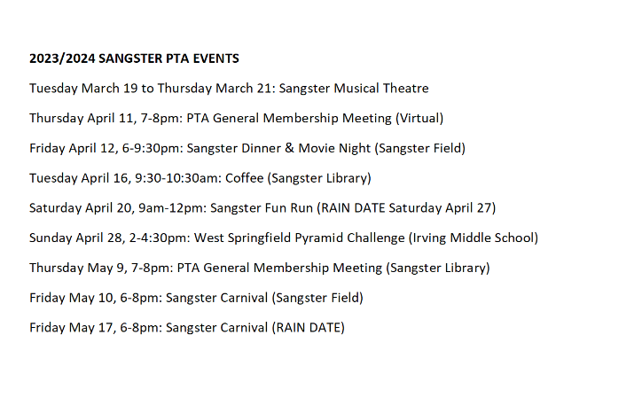
Membership: Margaret Lifsey
- Current members: 252
- School Directory now available at https://sangster.memberhub.com/directory
- For questions contact Margaret Lifsey sangsterptadirectory@gmail.com.
Volunteers: Tracy Winward
- We are always looking for volunteers! To sign up for the volunteer list, please scan the QR code below. Questions? Please email our PTA Volunteer Coordinator, Tracy Winward at sangsterptavolunteers@gmail.com.Sign up: Scan QR or visit https://forms.office.com/r/8NRp9sFfbP
The next meeting will be held virtually on April 11, 2024 @ 7pm.
Meeting adjourned at 7:29pm.

